GRN project notes

# A Gene Regulatory Network of Rheumatoid Arthritis

## Gene Regulatory Networks

Gene regulatory network are complex networks of interactions between genes, transcription factors, and other molecules that control gene expression.

* **Nodes and Edges**: Nodes represent genes/regulatory elements; edges represent interactions, such as activation or repression.​
* **Transcription Factors**: Bind to specific DNA sequences to regulate gene transcription. Regulate the transcription of target genes, turning them on or off. ​
* **Feedback Loops**: Create regulatory dynamics through self-influence. Can be positive or negative ​
* **Signal Integration**: Combines multiple signals from different pathways. Coordinates gene expression in response to stimuli. ​

There are 3 types of regulation:

* **Simple regulation**: transcription factor Y is activated by a signal, when active it binds to X to enhance its transcription rate ​
* **Positive Autoregulation**: X is a transcription factor that activates itself, ​
* **Negative Autoregulation**: X is a transcription factor that represses itself ​

### Simple regulation

Simple regulation occurs when transcription factor Y regulates gene X with no additional interactions. The regulation can either be activation or repression.

Activation:

$$Y→X$$

Repression:

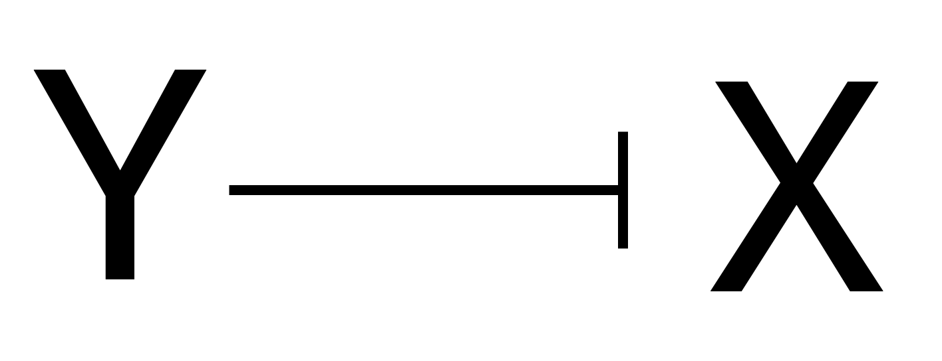

The production of protein X depends on the active state of transcription factor Y.

Equation for Activation:

$$\frac{dX}{dt}=β⋅Y−α⋅X$$

Where:

* $β$ = rate of production of X (depends on Y)
* $α$ = degradation rate of X
* X = concentration of X

Steady state is found by setting $\frac{dX}{dt}=0$:

$$X_{st}=\frac{β}{α}$$

Response time:

Time to reach 50% of steady state

$$T_{\frac{1}{2}}=\frac{ln\left(2\right)}{β}$$

From figure 1.d in the GRN review article $T_{\frac{1}{2}}$ for the simple regulation can be seen:

$$T_{\frac{1}{2}}=1\text{ cell generation}$$

Therefrom $β$ can be calculated as:

$$β=ln\left(2\right)$$

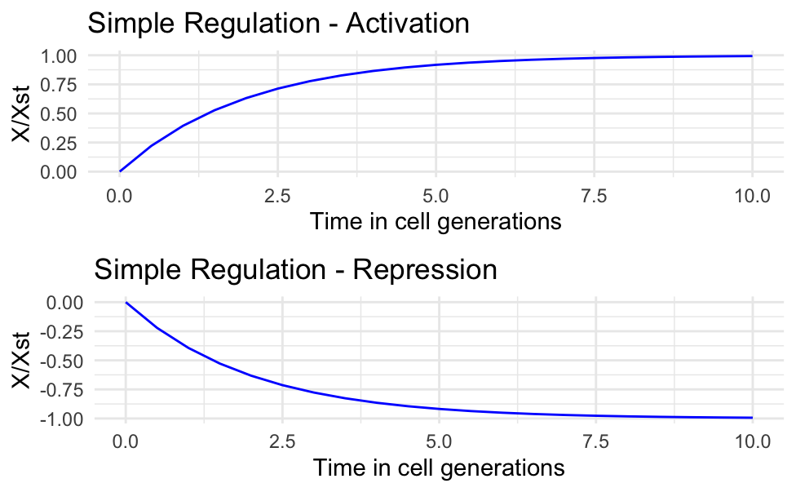

### **Negative Autoregulation**

In negative autoregulation, gene X represses its own expression, leading to faster response times and reduced variability.

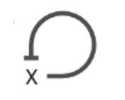

Equation for NAR:

$$\frac{dX}{dt}=\frac{β}{X+1}−α⋅X$$

Much simpler equation:

$$\frac{dX}{dt}=β−X−α⋅X$$

The Hill model:

$$f\left(x\right)=\frac{β}{1+{\left(\frac{X}{K}\right)}^{n}}$$

* K = repression coefficient
* n = hill coefficient

Extended equation:

$$\frac{dX}{dt}=\frac{β}{1+{\left(\frac{X}{K}\right)}^{n}}−α⋅X$$

Response time:

$$T_{\frac{1}{2}}=\frac{1}{2⋅β}$$

Response time for the extended model:

$$T_{\frac{1}{2}}=\frac{K}{2⋅β}$$

From figure 1.d in the GRN review article $T_{\frac{1}{2}}$ for the negative autoregulation can be seen:

$$T_{\frac{1}{2}}≈0.26\text{ cell generations}$$

Therefrom $β$ can be calculated as ($K=1$):

$$β=\frac{1}{2⋅T_{\frac{1}{2}}}=\frac{1}{2⋅0.26}=1.923$$

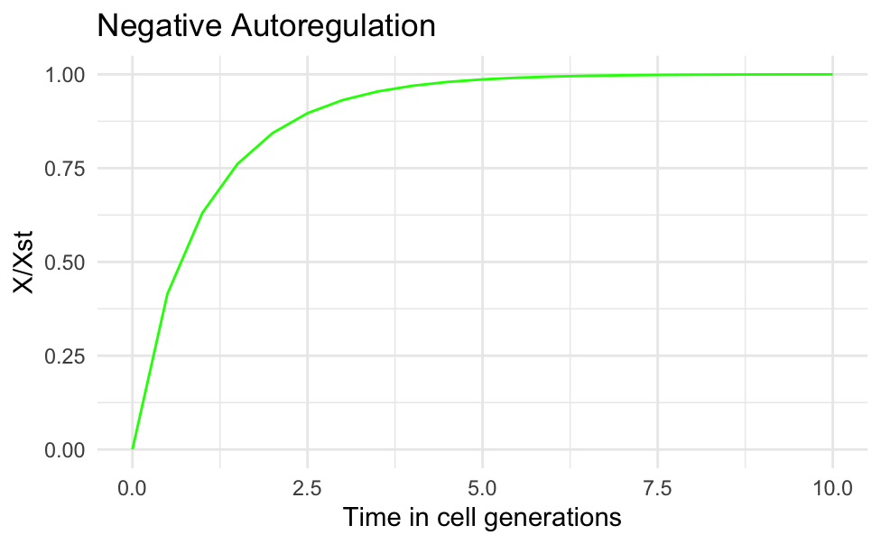

### **Positive Autoregulation**

In positive autoregulation, gene X enhances its own production, leading to slower response times and increased variability.

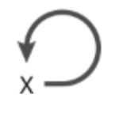

Equation for PAR:

$$\frac{dX}{dt}=\frac{β⋅X^{n}}{\left(K^{n}+X^{n}\right)}−α⋅X$$

Much simpler equation:

$$\frac{dX}{dt}=β+X−α⋅X$$

The Hill model:

$$f\left(x\right)=\frac{β}{1+{\left(\frac{K}{X}\right)}^{n}}$$

$X<K:f\left(x\right)<β$

$X>K:f\left(x\right)=β$

Response time:

more complicated…

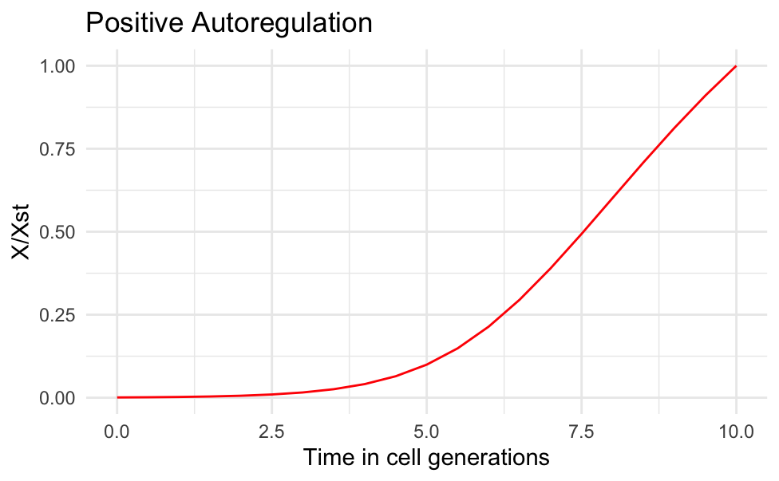

Plot of all 3 regulation types:

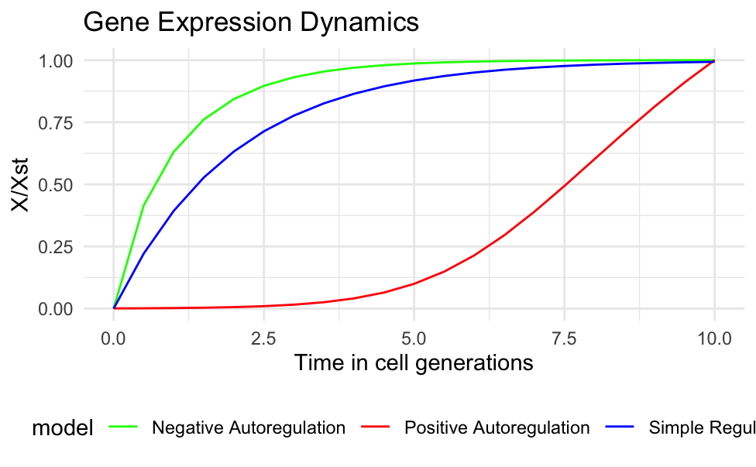

This Gene Expression Dynamics plot can be compared to Figure 1.d from the GRN review article:

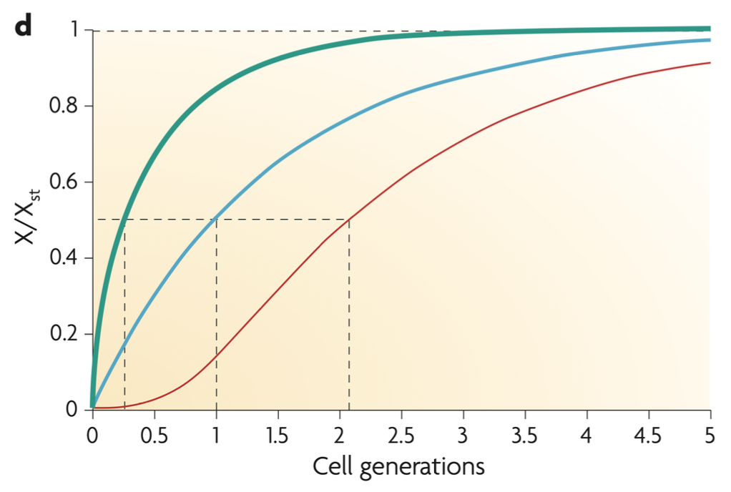

The Gene Expression Dynamics plot and Figure 1.d from the GRN review article are not identical. However, the shape of the curves for each of the 3 regulations are similar, indicating that I haven’t used the ‘correct’ parameter estimates for 𝛽 and 𝛼, as I had to guess the estimates in some cases. The models/equations used however seem to be implemented correctly.

## Feed Forward Loops

Consists of three genes: a regulator, X, which regulates Y, and gene Z, which is regulated by both X and Y. Because each of the three regulatory interactions in the FFL can be either activation or repression, there are eight possible structural types of FFL.

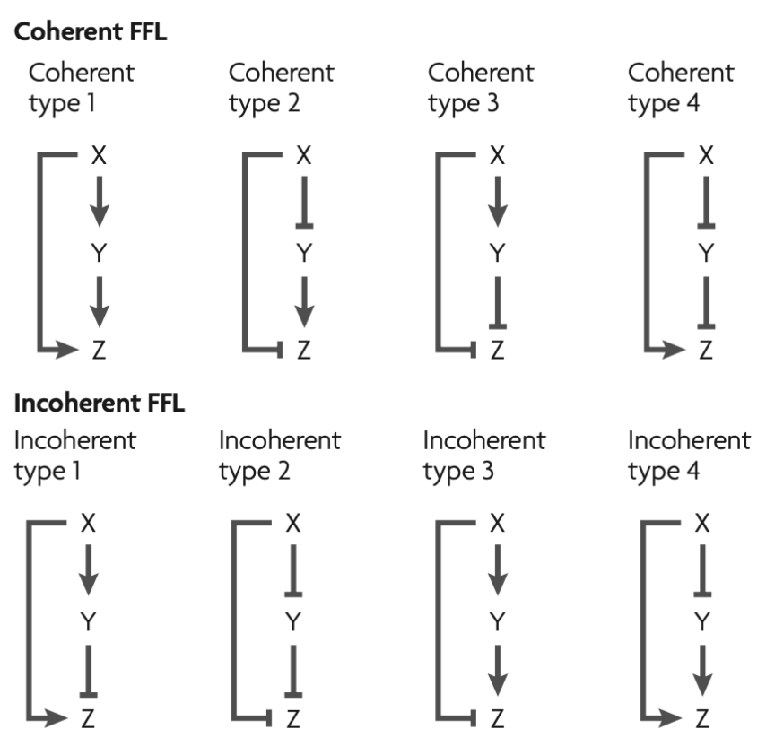

### Coherent FFL

In the C1-FFL, both X and Y are transcriptional activators

Equations for the coherent type 1 FFL:

$$\frac{dY}{dt}=f\left(X\right)−α⋅Y$$

* $f\left(x\right)$ can both describe activation and repression - dependent on the regulation

Activation of Z depends on an AND or an OR function:

*Two common ‘input functions’ are an ‘AND gate’, in which both X and Y are needed to activate Z, and an ‘OR gate’, in which binding of either regulator is sufficient*

OR function:

$$\frac{dZ}{dt}=f\left(X\right)+g\left(Y\right)−α⋅Z$$

AND function:

$$\frac{dZ}{dt}=f\left(X\right)⋅g\left(Y\right)−α⋅Z$$

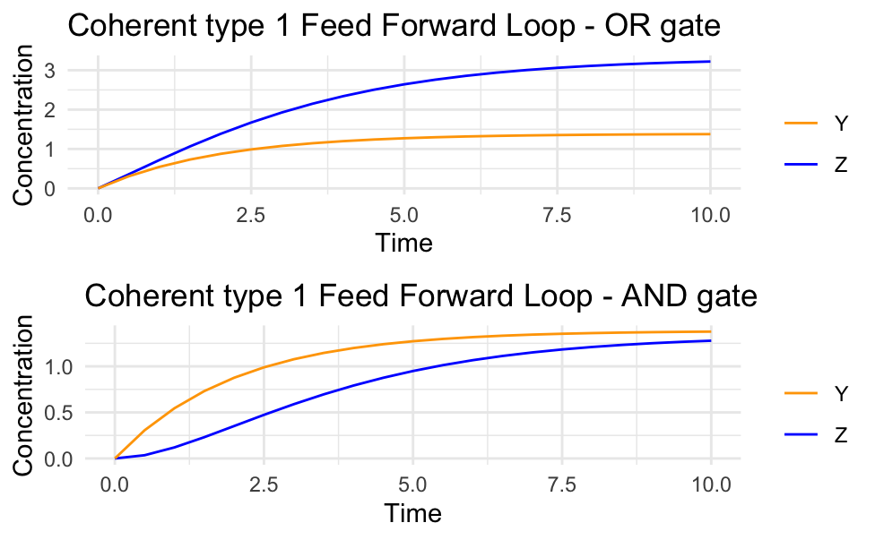

### Incoherent FFL

In the I1-FFL, the two arms of the FFL act in opposition: X activates Z, but also represses Z by activating the repressor Y.

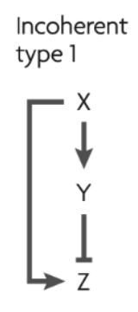

Equations for the incoherent type 1 FFL:

$$\frac{dZ}{dt}=f\left(x\right)−α⋅Y$$

OR function:

$$\frac{dZ}{dt}=f\left(X\right)+g\left(Y\right)−α⋅Z$$

* $g\left(Y\right)$ is a repression function

AND function:

$$\frac{dZ}{dt}=f\left(X\right)⋅g\left(Y\right)−α⋅Z$$

* $g\left(Y\right)$ is a repression function

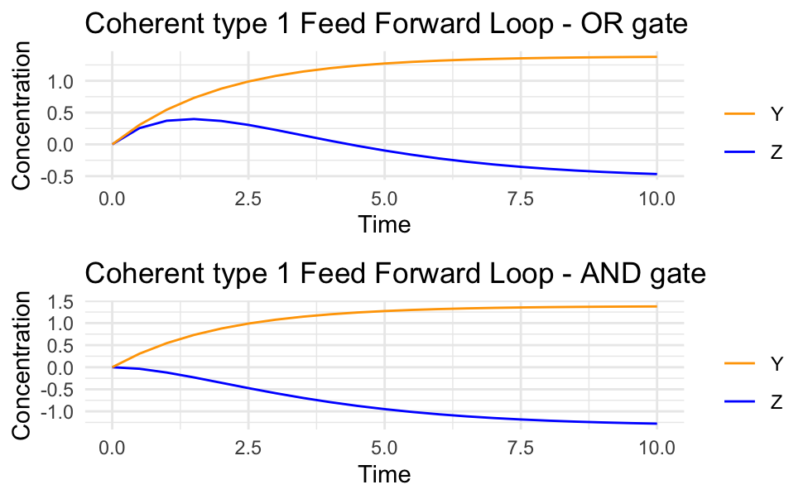

## Introduction and pathophysiology

Rheumatoid arthritis (RA) is a systemic autoimmune disease driven by T-cells characterized by inflammatory arthritis. It is a chronic inflammatory disorder caused in many cases by the interaction between genes and environmental factors. 50% of the risk for development of RA is attributed to genetic factors. If untreated RA leads to severe joint and bone damage, disability, and deformity. RA is not limited to joint damage. The chronic inflammation can spread to other organs, affecting the cardiovascular system (increased risk of heart disease), lungs (interstitial lung disease), and even the eyes and skin.

It affects around 0.5–1% of people worldwide and 0.8% of the danish population. Women are 3 times more likely to be diagnosed with RA than men. Each year around 1700 people is diagnosed with the disease in dk.

(Thus, developing a model that can predict the behaviour of this gene network would be relevant to better understand this irreversible disability.)

The immune system becomes dysregulated and mistakenly targets the body’s own tissue, particularly the joints. Autoantibodies, along with immune cells like T cells and B cells, infiltrate the synovium (the membrane lining the joints). They release pro-inflammatory cytokines such as tumor necrosis factor-alpha (TNF-α), interleukin-1 (IL-1), and interleukin-6 (IL-6). These molecules drive inflammation, attracting more immune cells and amplifying the immune response.

All this leads to swollen and painful joints, morning stiffness, decreased range of motion, deformities.

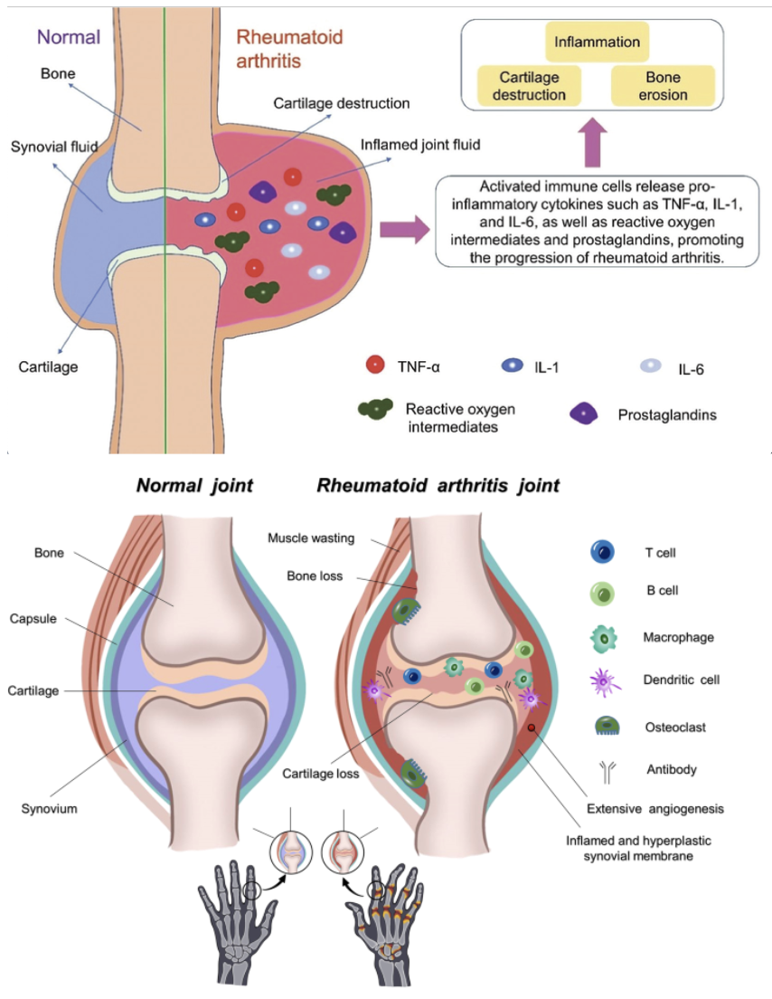

Fig. 2| Normal and rheumatoid arthritis joints. Joint swelling in RA reflects synovial inflammation due to immune activation. The cellular composition of RA synovitis is characterized by the accumulation of innate and adaptive immune cells (e.g., T cells, dendritic cells, B cells, macrophages, and osteoclasts). Pro-inflammatory and bone-destructive factors of the immune response led to the loss of bone or cartilage with synovial thickening, angiogenesis, and muscle wasting. Extracted from: ​[1]​.

### The genes behind the disease

The main signalling pathways and the focus for current and new treatment research in RA are NF-κB, MAPK, PI3K-AKT, Wnt, and JAK-STAT ​[2]​.

NF-κB is one of the most common pathways in RA and is often associated with inﬂammatory responses. NF-κB is a dimer transcription factor associated with the production of several pro-inﬂammatory factors (TNF-α, IL-1β, and IL-6) in RA. NF-κB can cause synovial inﬂammation by prompting macrophages to release inﬂammatory factors ​[2]​.

Many diseases, including cancer, and inflammatory and autoimmune diseases, are associated with dysregulation of NF-κB.

* Transcriptional factors:
  + NF-kB : An obvious sign of RA occurrence is the activation of NF-κB. The expression of NF-κB in the synovium of RA patients was significantly increased. activation through positive feedback.
  + AP1: its expression is related to the severity of the disease
* The JAK/stat pathway is associated with a variety of cytokines
* (PI3K)-Akt plays an important role in cell physiology, regulating cell differentiation, proliferation, autophagy
* The Wnt pathway plays a role in a variety of cancers and immune diseases and is related to various physiological processes, including cell proliferation and migration

**[Image missing]**

Genes behind immune response (CD97, FYB, CXCL1, IKBKE, CCR1, etc.), inflammatory response (CD97, CXCL1, C3AR1, CCR1, LYZ, etc.) and homeostasis (C3AR1, CCR1, PLN, CCL19, PPT1, etc.) have a major impact in RA ​[3]​.

### State of the art in modelling this disease

The current standard treatment for Rheumatoid Arthritis (RA) is the use of DMARDs (Disease-Modifying Antirheumatic Drugs), covering a wide range of drugs targeting inflammatory pathways. A more recent and trending treatment approach is the use of JAK inhibitors, which specifically target the JAK-STAT pathway, and reduces inflammation.

The genetic components of RA are well studied, and with a deeper understanding of patient-specific immune profiles and genetic variations, personalised treatments can be tailored to optimize outcomes, minimize side effects, and potentially target the disease earlier.   
[Recent progress in treatments of rheumatoid arthritis: an overview of developments in biologics and small molecules, and remaining unmet needs - PMC (nih.gov)](https://pmc.ncbi.nlm.nih.gov/articles/PMC8709568/)

While the mechanisms of inflammation are well understood, the precise triggers that initiate this chronic inflammatory state are not understood completely. Understanding these initiation mechanisms is crucial for preventing RA onset and developing therapies that target the disease before it progresses.

The last 20-30 years various types of mathematical models have been developed. These models range from ordinary differential equation (ODE) models that simulate the temporal dynamics to stochastic and agent-based models that capture the variability and unpredictability of immune responses in different patients. Also, pharmacokinetic (PK) and pharmacodynamic (PD) models have helped to optimize treatment strategies.

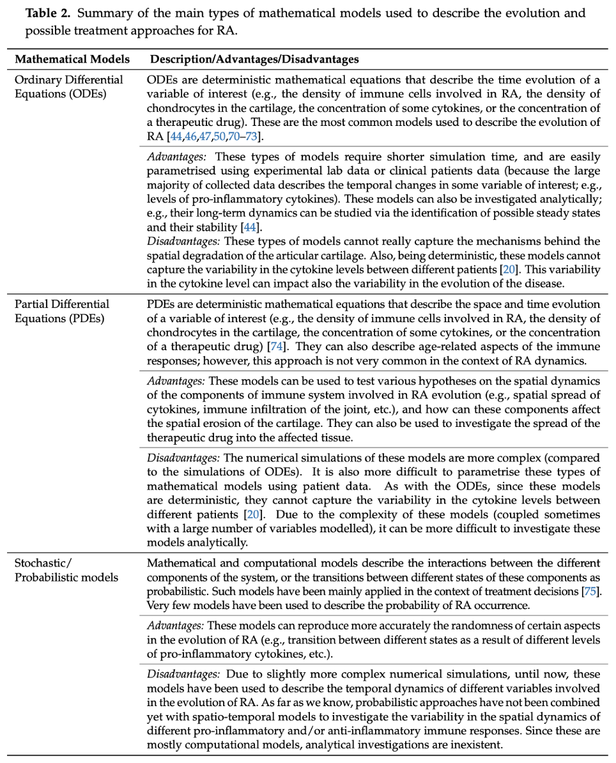  
<https://pmc.ncbi.nlm.nih.gov/articles/PMC7016994/>

### Project goal and aim

Goals:

* To model the GRN for NF-kB pathway in rheumatoid arthritis ​
* Investigate/analyze different components/parameters to determine their impact on the pathway ​

Aims:

* To gain a deeper understanding of the molecular mechanisms driving rheumatoid arthritis​
* Identify Key Regulatory Elements: Pinpoint critical components of the NF-κB pathway that influence disease progression​

**Future perspective**​ - Help to develop targeted therapies

* Identify potential therapeutic targets for more effective treatments.​

## The NF-KB pathway

We are looking into two different pathways of NF-kB – the canonical which is the most studied and the non-canonical. ​

In resting cells, NF-κB is typically bound to an inhibitor protein (IκB), which keeps it in the cytoplasm. Upon receiving a signal (e.g., from cytokines, stress, or pathogens), IκB is degraded, freeing NF-κB to move into the nucleus. ​Once in the nucleus, NF-κB binds to specific DNA sequences in the promoter regions of target genes, activating or repressing their transcription.​

Canonical pathway: This pathway responds to pro-inflammatory signals like tumor necrosis factor (TNF) and interleukin-1 (IL-1).​

Non-canonical pathway: Which unlike the canonical pathway, that is rapidly activated and involves a broad range of stimuli, the non-canonical pathway is more selective and slower in its activation. It can be activated by Lymphotoxin-beta, CD40 ligand, or B-cell activating factor. ​The NF-kB inducing kinase (NIK) is responsible for initiating the signal cascade. The non-canonical pathway uses IKK-alpha instead of the complexes that also include IKK-beta. IKK-alpha phosphorylates p100 which is a precursor to p52. This creates the p52/relB complex that when moved to the nucleus regulates target gene expression. ​

​

As a start of the modeling of this project we wanted to compute a simple model of the canonical pathway to investigate which parameters are important. ​

**[Image missing]**

Since we have not had the time to investigate the parameters yet our hypothesis very broad so far.​

​**The progression of rheumatoid arthritis is driven by dysregulated NF-κB pathway dynamics, where specific components and parameters, such as cytokine signaling, feedback inhibition, and gene regulatory interactions, play critical roles in sustaining chronic inflammation. By modeling the NF-κB gene regulatory network (GRN), we can identify key regulatory elements and their impact on disease progression, providing insights into potential therapeutic targets.**

​Which is that we from our model can identify key regulatory elements and their impact on the progression/development of RA by modelling different NF-kB pathways and comparing them. This will hopefully provide insights into potential therapeutic targets. ​

​

Non-canonical: This pathway is involved in immune system development and is activated by specific signals like lymphotoxin β. lymphotoxin β (LT-Beta or formerly known as TNF-C) is encoded by LTB gene which promotes profileration of Rheumatoid Arthritis Fibroblast-Like Synoviocytes, Invasion and Inflammation, While Inhibits Apoptosis Via Activating Lymphotoxin Beta Mediated NF-kappaB Signaling Pathway[1]. The TNF receptor associated factors (TRAF)-2, 3 and 5 function as adaptors linking LTβR signaling targets[2].​

(<https://www.ncbi.nlm.nih.gov/gene/4050#:~:text=3%20Promotes%20Rheumatoid%20Arthritis%20Fibroblast,Mediated%20NF%2DkappaB%20Signaling%20Pathway>.)​

(<https://www.ncbi.nlm.nih.gov/books/NBK6515/#:~:text=The%20lymphotoxin%2D%CE%B2%20receptor%20(LT%CE%B2R,adaptors%20linking%20LT%CE%B2R%20signaling%20targets>.)​

​

### Equations and parameters

For modelling the canonical pathway of NF-kB we have made a very simple model containing 3 coupled ordinary differential equations (ODEs):

$$\frac{\left[A_{IKK}\right]}{dt}=R⋅β_{1}−α_{1}⋅\left[A_{IKK}\right]$$

$$\frac{\left[I\right]}{dt}=\left[A_{IKK}\right]⋅β_{2}−α_{2}⋅\left[I\right]$$

$$\frac{\left[P\right]}{dt}=\left[A_{IKK}\right]⋅β_{3}−β_{4}⋅\left[I\right]−α_{3}⋅\left[P\right]$$

where [$A_{IKK}$] is the concentration of the IKK complex, [I] is the concentration of I $κ$ B $α$, and [P] is the concentration of NF- $κ$ B. $β_{1}$, $β_{2}$, and $β_{3}$ are production rates and $α_{1}$, $α_{2}$, and $α_{3}$ are degradation rates of IKK complex, I $κ$ B $α$, and NF- $κ$ B, respectively, where $β_{4}$ is an inhibitory rate of NF- $κ$ B.

The generation of the equations from the canonical pathway of NF- $κ$ B are shown below.

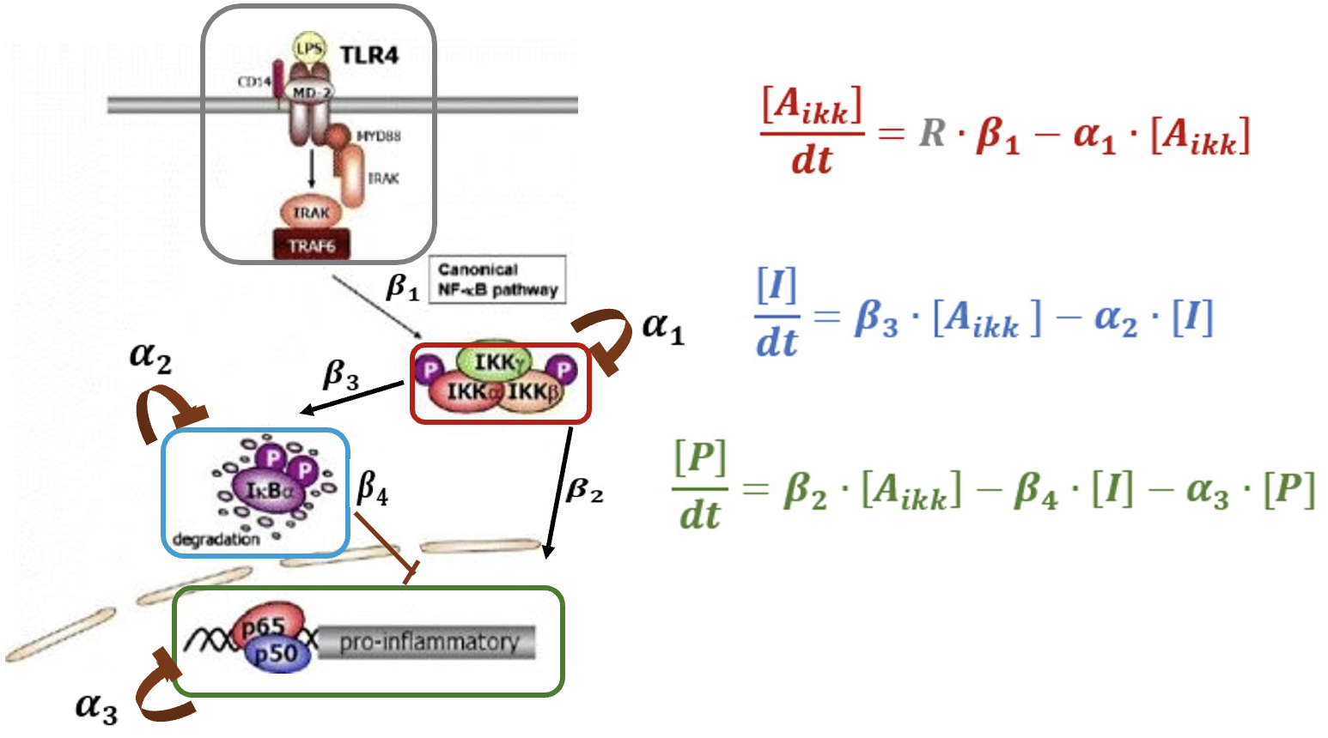

For out model we are using the parameter values presented by Jaruszewicz-Błońska et al.

| Parameter | Value | Description |
| --- | --- | --- |
| $α_{1}$ | 0.00145 $s^{−1}$ | Spontaneous inactivation of IKK complex |
| $α_{2}$ | 0.0763 $s^{−1}$ | IκBα degradation induced by IKK complex |
| $α_{3}$ | 0.043278 $s^{−1}$ | IκBα and A20 synthesis (leading to degradation of NF-κB), and Michaelis-Menten type constant (NF-κB inactivation) |
| $β_{1}$ | 0.00195 $s^{−1}$ | Activation of IKK comple |
| $β_{2}$ | 0.0946 $s^{−1}$ | IKK (IκBα|NF-κB) association |
| $β_{3}$ | 0.0946 $s^{−1}$ | IKK (IκBα|NF-κB) association |
| $β_{4}$ | 0.000595 $s^{−1}$ | IκBα nuclear import leading to… (repression of NF-κB) |

### Model visualisation

The simple model has been visualised by plotting the concentration of each component over time.

**[Image missing]**

In the plot above the components initial concentrations were set to zero, as we didn’t have any idea of what the initial values should be. When searching the literature we found that the baseline concentrations are very low, and one article mentioned a threshold for NF- $κ$ B of 20nM (0.02µM).

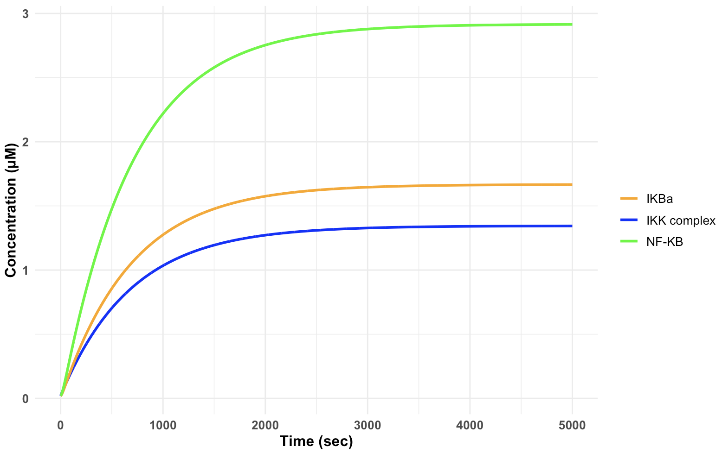

You can see in the plot above that changing the initial values to 0.02µM didn’t make any big difference. In the plot above the time period has been increased to 5000 sec (83,33 min or 1,39 h) to better see that the components reach a steady state concentration.

#### Defining activation period

We than made a little change to the model so in stead of the pathway either being active or inactive, a specific time period or multiple time periods for activation can be selected.

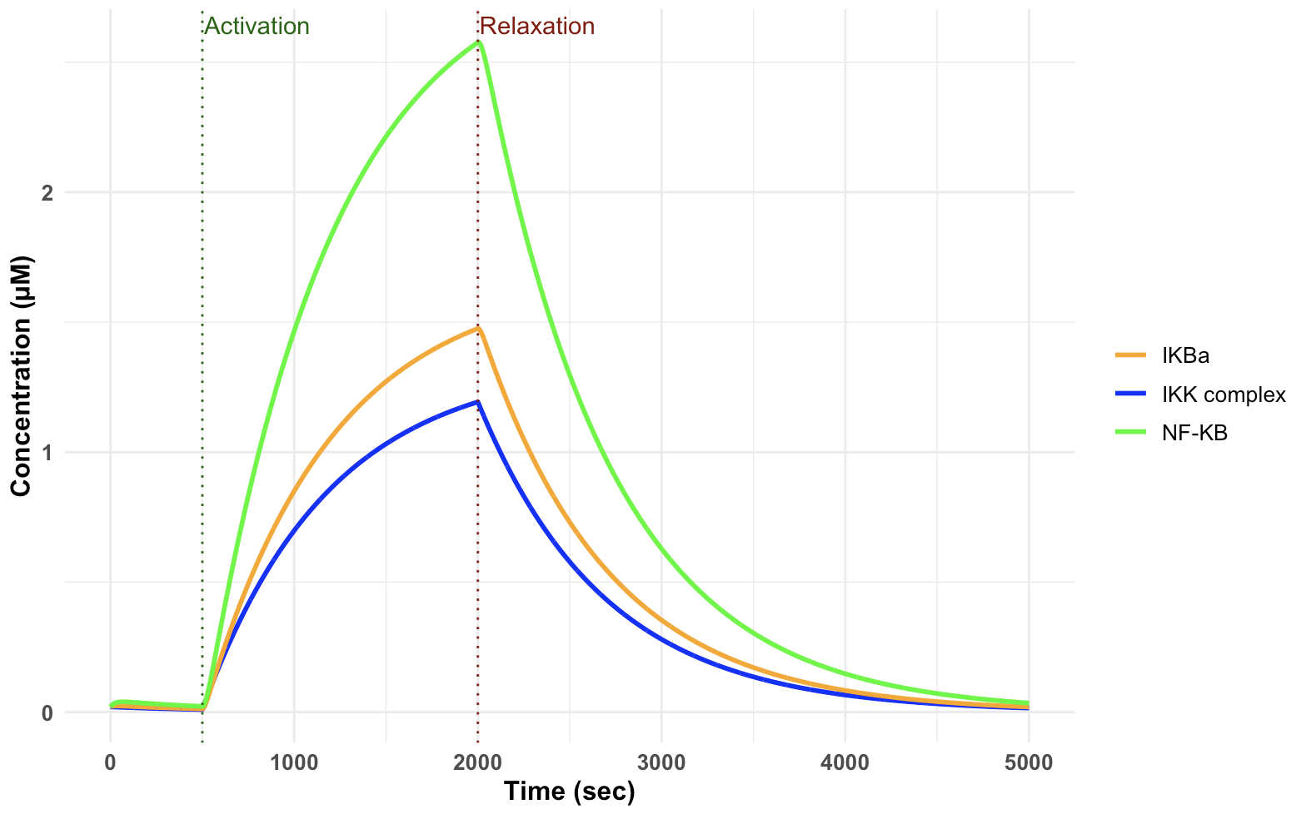

#### Multiple activation periods:

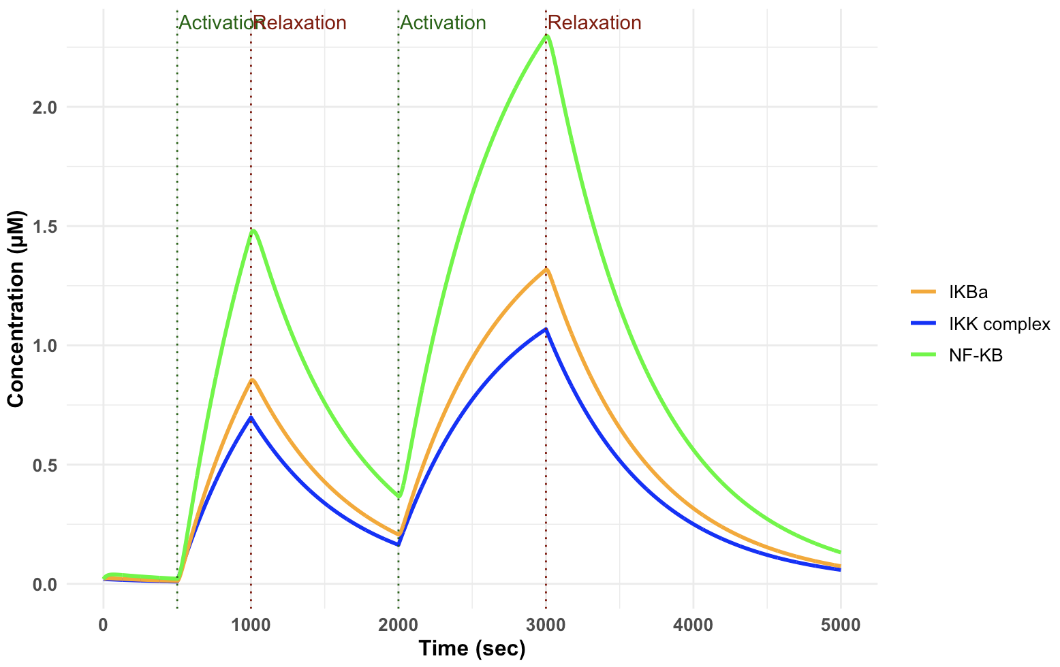

### Sensitivity analysis

* The **left panel** shows **first-order Sobol’ indices**, representing the individual effect of each parameter on the model output.
* The **right panel** shows **total Sobol’ indices**, representing the overall effect, including interactions with other parameters.

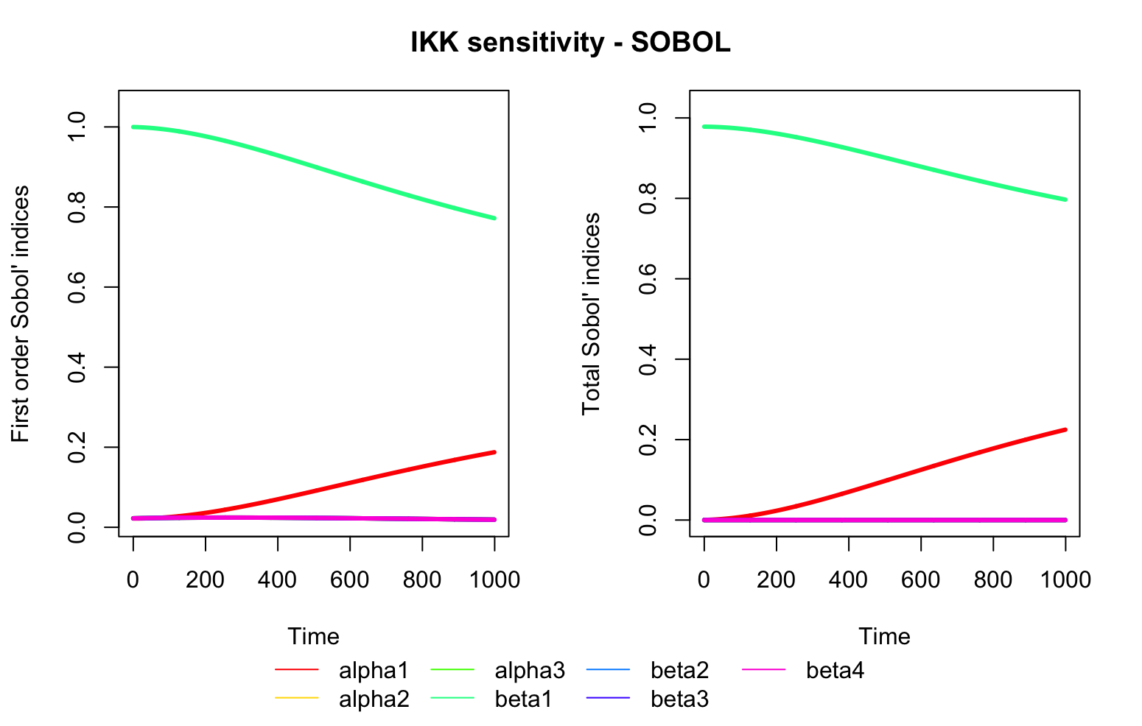

In the plot, the green line ($α_{3}$ ​) has the highest first-order and total Sobol’ indices over time, indicating that it has the most significant influence on the IKK complex. This suggests that variations in $α_{3}$ ​ have a strong effect on the IKK complex response. Other parameters, particularly $α_{1}$ ​ and $β_{4}$ ​, have a lower impact on the IKK complex, as shown by their lower indices.

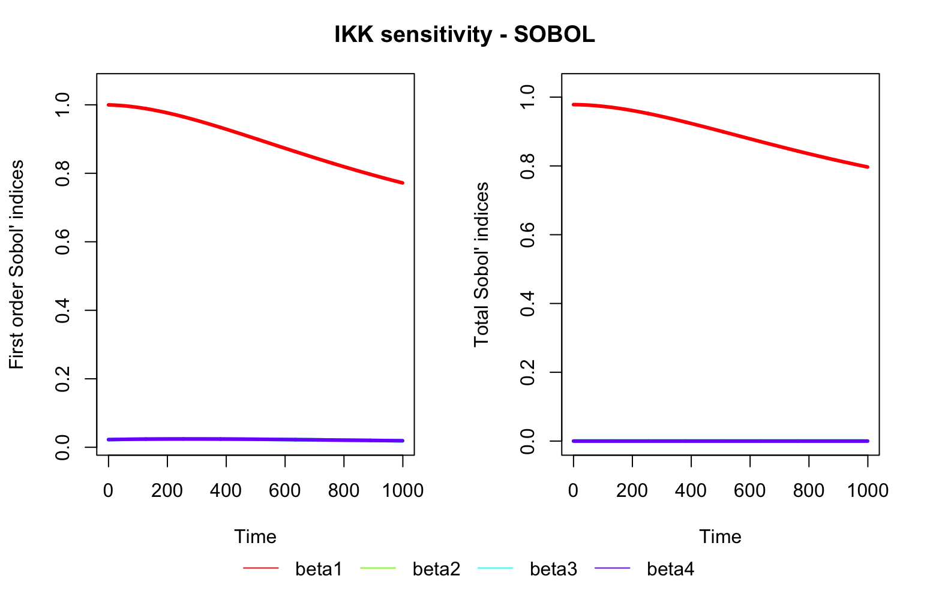

When only looking at the beta parameters we see that beta1 has a substantial influence on the output, with an index close to 1 that gradually decreases over time, indicating that this parameter is the primary driver of the model output for IKK with minimal contribution from the other parameters (first order and total Sobol’ indices).

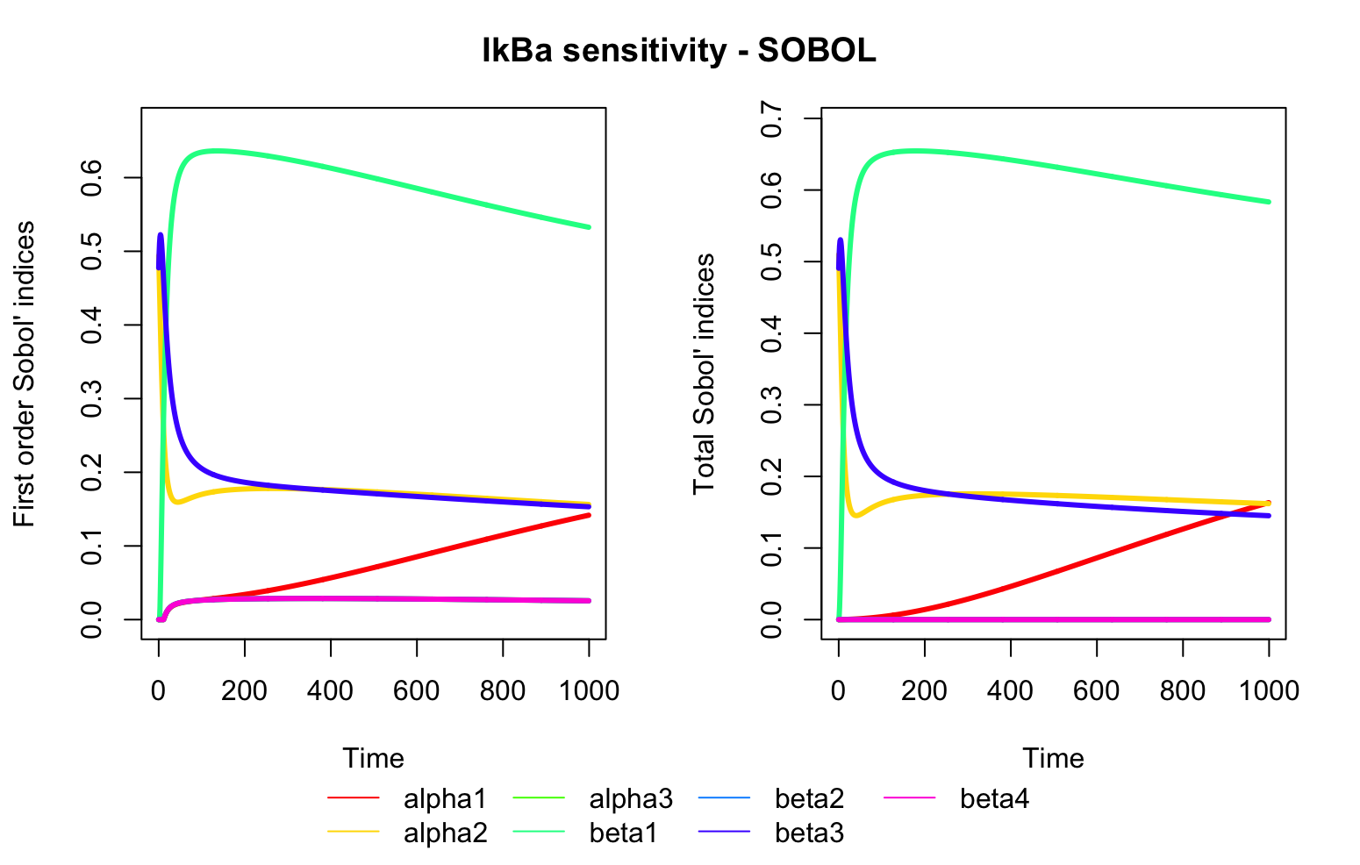

Initially, $α_{3}$ ​ dominates the first-order and total indices but decreases over time. This implies that $α_{3}$ ​ is initially influential but becomes less significant. Parameters like $β_{2}$ and $α_{1}$ ​ gain relevance as time progresses, particularly for total indices, which may indicate a cumulative or indirect influence.

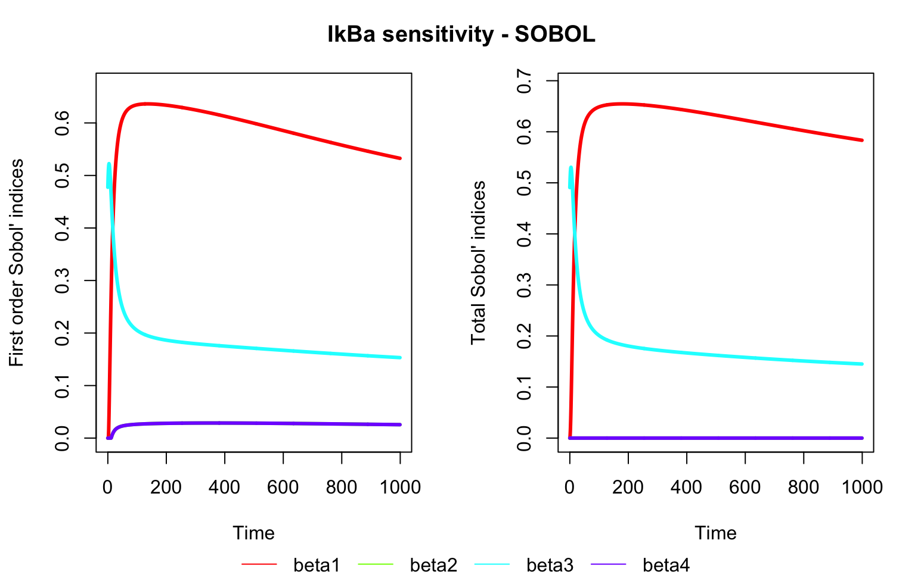

When only looking at the beta parameters influence on I $κ$ B $α$ we see that both $β_{1}$ and $β_{3}$ initially have high first order Sobol’ indices, with $β_{1}$ peaking early and gradually decreasing, while $β_{3}$ starts high and decreases more quickly. This suggests that both parameters have a significant impact on IκBα, especially early on. $β_{1}$ and $β_{3}$ also dominate the total indices, where the higher total index values for $β_{1}$ suggest that its influence persists longer and includes interactions, while $β_{3}$ has a strong early impact but diminishes over time.

This pattern suggests that the dynamics of IκBα depend primarily on $β_{1}$ and $β_{3}$, with a shift in dominance from $β_{3}$ to $β_{1}$ as time progresses

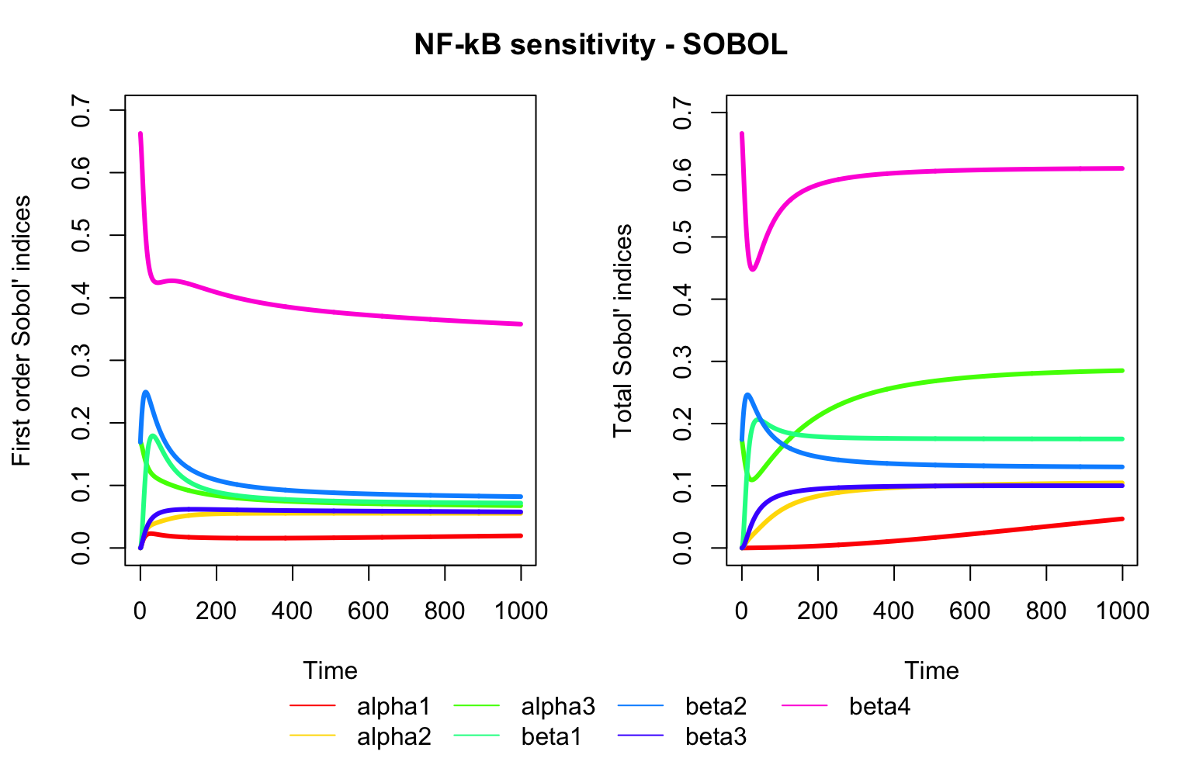

$β_{4}$ has the highest first-order Sobol’ index at the start, showing it has the largest direct effect on NF-κB initially. However, it stabilizes over time . $α_{3}$ ​ and $β_{2}$ ​ contribute significantly as well, with consistent indices, suggesting these parameters influence NF-κB throughout the simulation.

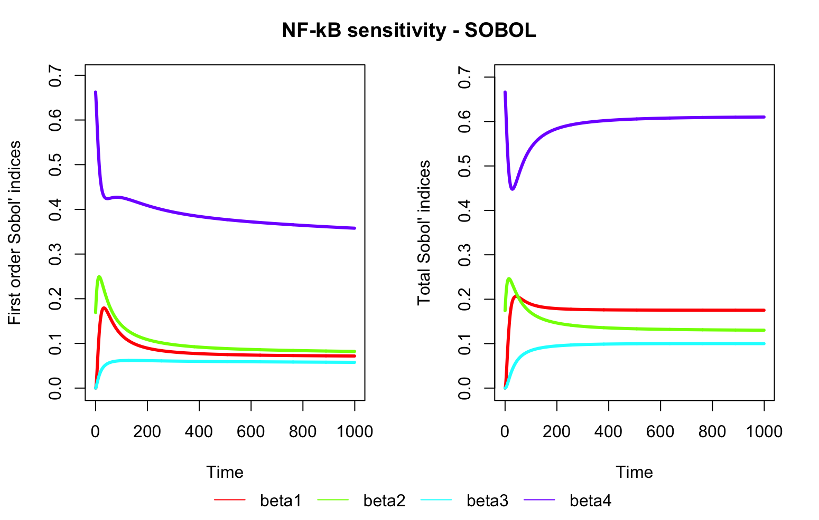

When only looking at the beta parameters influence on NF- $κ$ B we see that for the first order Sobol’ indices $β_{4}$ is the dominant parameter early on, with a high index that gradually decreases over time, while other parameters have much lower but nonzero indices, suggesting some influence. $β_{4}$ remains the most significant parameter throughout, with high total Sobol’ indices suggesting strong direct and interactive effects. However, $β_{1}$, $β_{2}$, and $β_{3}$ also have non-negligible total indices, indicating that their interactions contribute to the NF-κB output sensitivity.

This implies that while $β_{4}$ is the key driver, interactions among $β_{1}$, $β_{2}$, and $β_{3}$ also play a role, particularly in the early dynamics of NF-κB.

### Initial values - ChatGPT

#### IKK Complex

* **Total IKK Complex Concentration**: In many studies, IKK is present at around 10-100 nM in unstimulated cells, though its active form (IKKa or IKKβ) is generally very low at baseline due to the lack of stimulation.
* **Activated IKK**: When stimulated (e.g., by TNF-α), activated IKK levels can reach up to 1-10 nM, depending on the stimulus strength and duration, before returning to low levels due to feedback inhibition by proteins like A20 and other regulatory mechanisms.

#### IκBα/NF-κB Complex

* **IκBα Concentration**: IκBα is typically present at levels around 10-100 nM in resting cells, which is sufficient to sequester NF-κB in the cytoplasm. After a stimulus is applied, IκBα can rapidly degrade, allowing NF-κB to translocate to the nucleus.
* **Cytoplasmic NF-κB (Inactive Complex)**: The NF-κB held in the cytoplasm by IκBα is generally around 10-20 nM in unstimulated cells, as observed in some experimental systems.
* **Nuclear NF-κB (Active Form)**: Upon activation, NF-κB concentration in the nucleus can transiently rise to 1-5 nM before feedback mechanisms downregulate its activity. This nuclear concentration is more variable because it depends on the strength and nature of the stimulus.

### Biological relevance

We have found a pure biological paper that illustrates what the dynamics should look like…

Result 1

The simple model doesn’t seem to represent biology correctly

* I think it might be due to the low inhibition rate of NF- $κ$ B by I $κ$ B $α$

## Expanded canonical and non-canonical pathway

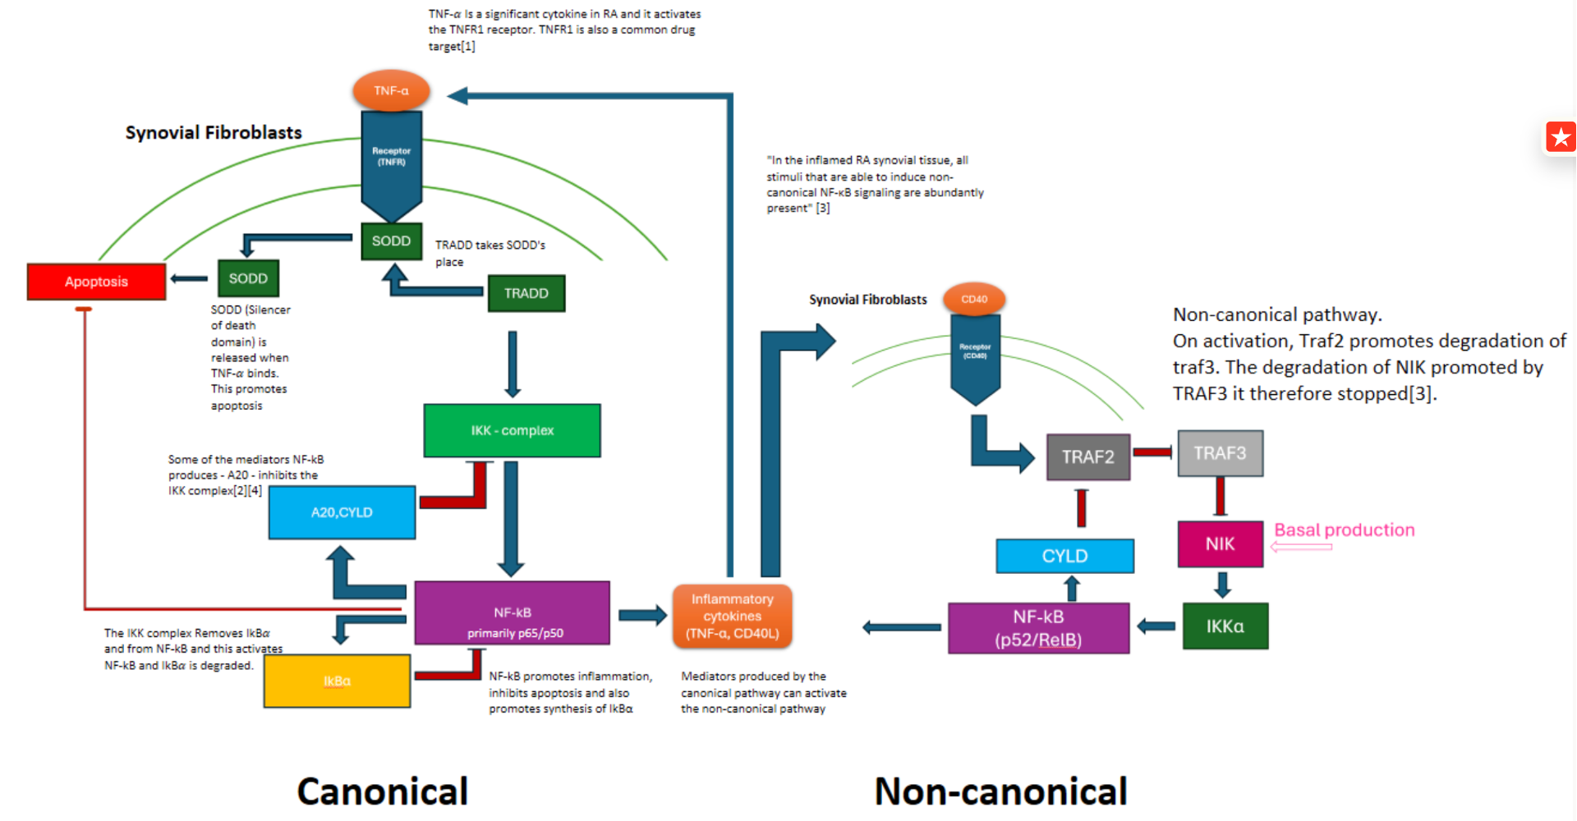

Marie made the above model proposal, that expands our existing canonical pathway, includes the non-canonical pathway, and shows how the two are connected.

### Expanding the canonical pathway

From Marie’s model proposal I (Amy) have made some differential equations for the expanded canonical pathway. First where the NF- $κ$ B/I $κ$ B $α$ separation by activation by the IKK complex is modelled as in the simple NF- $κ$ B model:

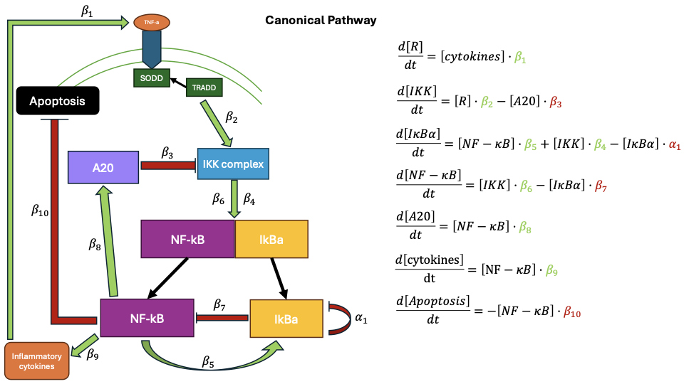

And another where the NF- $κ$ B/I $κ$ B $α$ separation activated by the IKK complex is modelled as the IKK complex activating NF- $κ$ B and degrading I $κ$ B $α$:

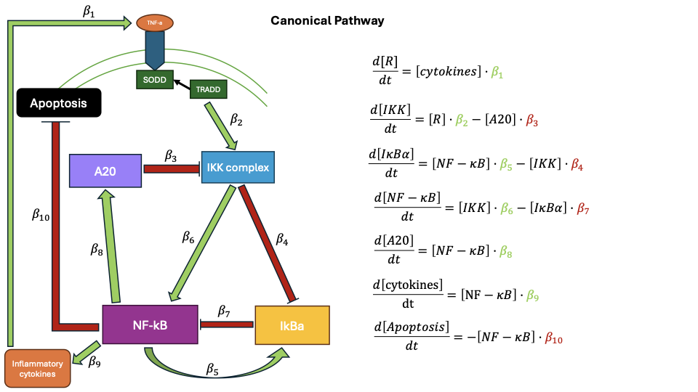

We decided to to go with the first suggestion, but with modifications as we want the model to as biologically correct as possible. We therefore included the NF- $κ$ B and I $κ$ B $α$ complex in the model.

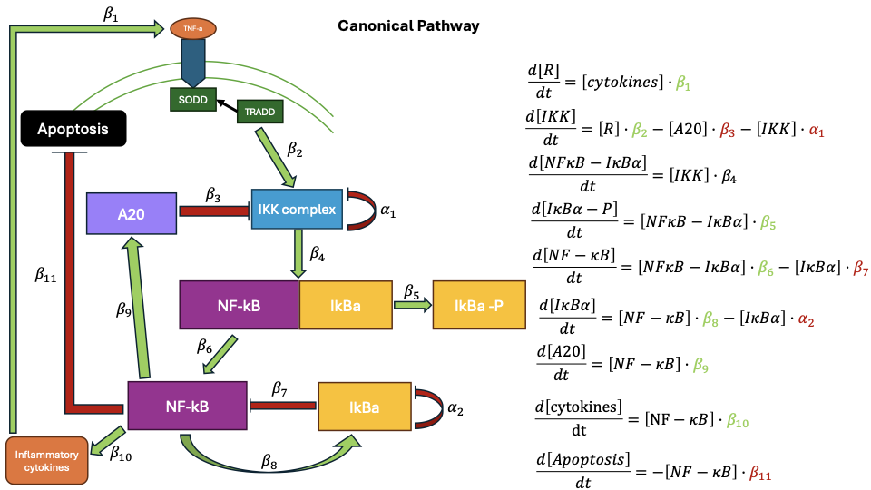

From the NF- $κ$ B and I $κ$ B $α$ complex I $κ$ B $α$ is phosphorylated/degraded and NF- $κ$ B is released.

Next steps for the canonical pathway:

* Reevaluate the new expanded model and make sure it is correct
* Visualise the expanded model with R
* Change the x-axis to be in minutes or hours instead of seconds
* Sensitivity analysis of the initial values (in stead of trying to find them in the literature)
* Maybe expand the model even more and add free and nuclear NF-kB
* Move between states
* Include the feedback mechanism of IkBa binding to NF-kB creating new complexes
* AND or OR function for the IkBa - NF-kB complex to see how they effect each other
* include hill function in the equations if needed

### The non-canonical pathway

A separate model has been made for the non-canonical part of the NF- $κ$ B pathway:

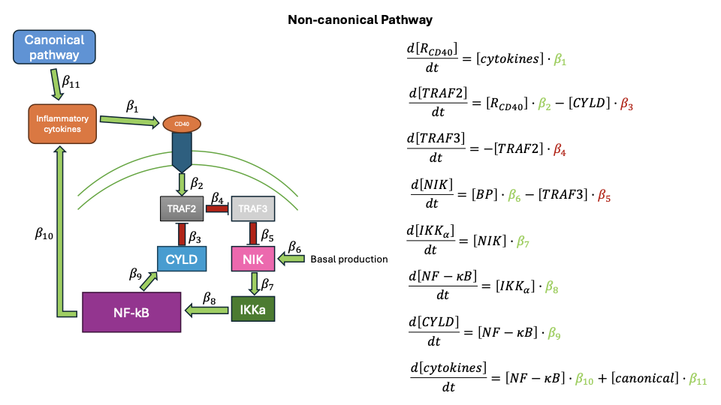

## New canonical model

We had difficulties with the differential equations, so we tried reproducing a model from a paper by Jaruszewicz-Błońska et al.

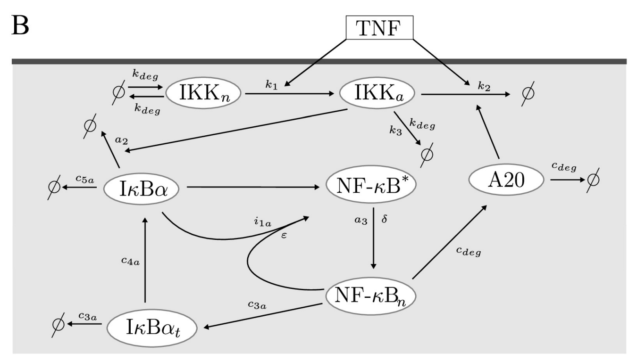

Inactivated IKK

$$\frac{d\left[IKKn\right]}{dt}=k_{deg}−k_{deg}⋅IKK_{n}−R⋅k_{1}⋅IKK_{n}$$

Activated IKK

$$\frac{d\left[IKK_{a}\right]}{dt}=R⋅k_{1}⋅IKK_{n}−\left(k_{3}+k_{deg}\right)⋅IKK_{a}−R⋅k_{2}⋅A20⋅IKK_{a}$$

Nuclear NF- $κ$ B

$$\frac{d\left[NFkB_{n}\right]}{dt}=a_{3}⋅IKK_{a}⋅\left(1−NFkB_{n}\right)⋅\frac{δ}{IkBa+δ}−i_{1a}⋅IkBa⋅\frac{NFkB_{n}}{NFkB_{n}+ϵ}$$

A20

$$\frac{d\left[A20\right]}{dt}=c_{deg}⋅NFkB_{n}−c_{deg}⋅A20$$

I $κ$ Ba

$$\frac{IkBa}{dt}=c_{4}⋅IkBa_{t}−c_{5a}⋅IkBa−a_{3}⋅IKK_{a}⋅\left(1−NFkB_{n}\right)⋅\frac{IkBa}{IkBa+delta}−i_{1a}⋅IkBa⋅\frac{NFkB_{n}}{NFkB_{n}+ϵ}$$

I $κ$ Ba mRNA

$$\frac{d\left[IkBa_{t}\right]}{dt}=c_{3a}⋅NFkB_{n}−c_{3a}⋅IkBa_{t}$$

Validating that we have reproduced the model correctly, by comparing to their the results in the article.

Our initial values:

x0 <- c(IKKn = 0.02, IKKa = 0, NFkBn = 0.02, A20 = 0.02, IkBa = 0.02, IkBat = 0.02)

From the article:

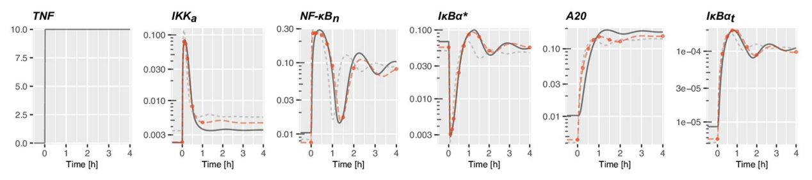

Our results:

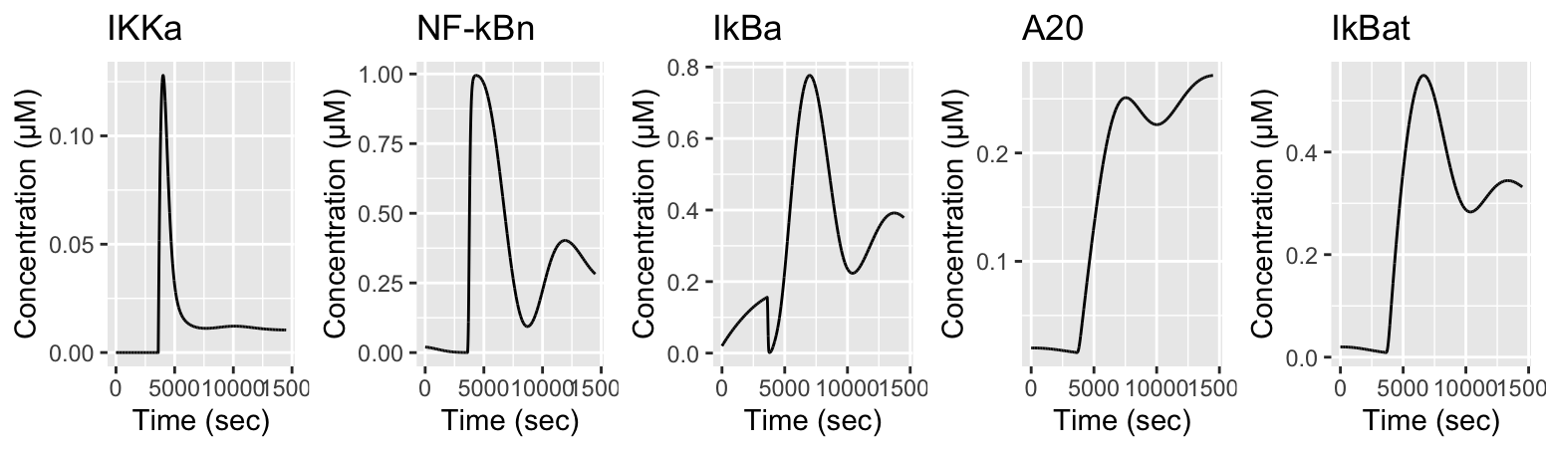

3 activation periods:

t_start <- c(0,5400, 10800) # Start time for activation

t_end <- c(2700,8100,13500) # End time for activation

Their results:

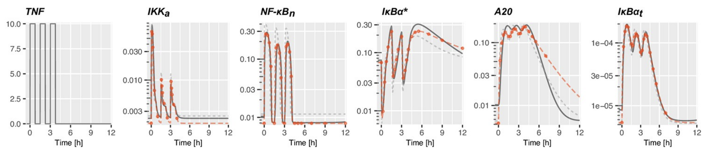

Our results:

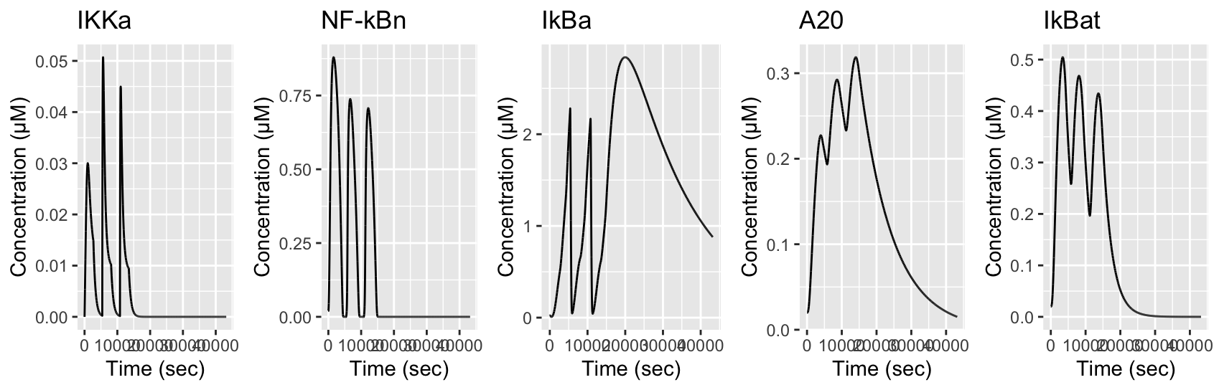

### Tweaking the model

When TNFa (the receptor) is inactive we would expect the concentrations to be constant. But with the model we do not observe this for IkBa:

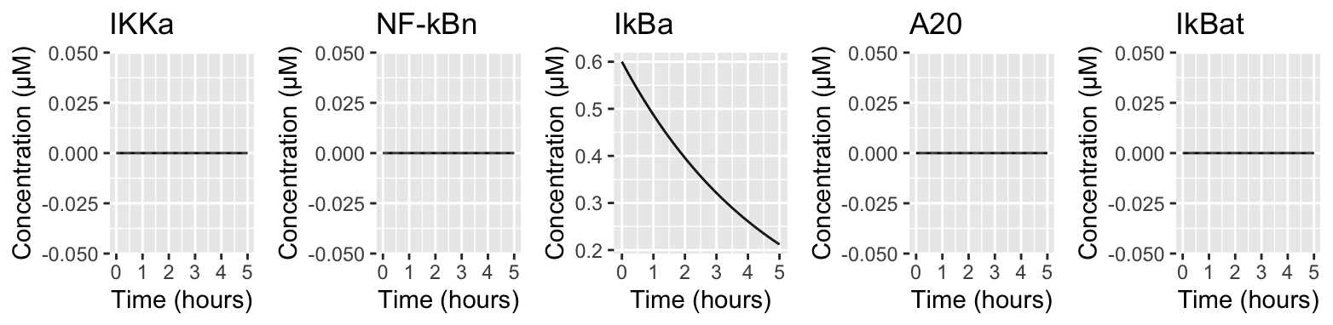

Therefore we have decided to remove the spontaneous degradation of IkBa (C5a*IkBa) from the model, so the degradation only is induced by IKKa.

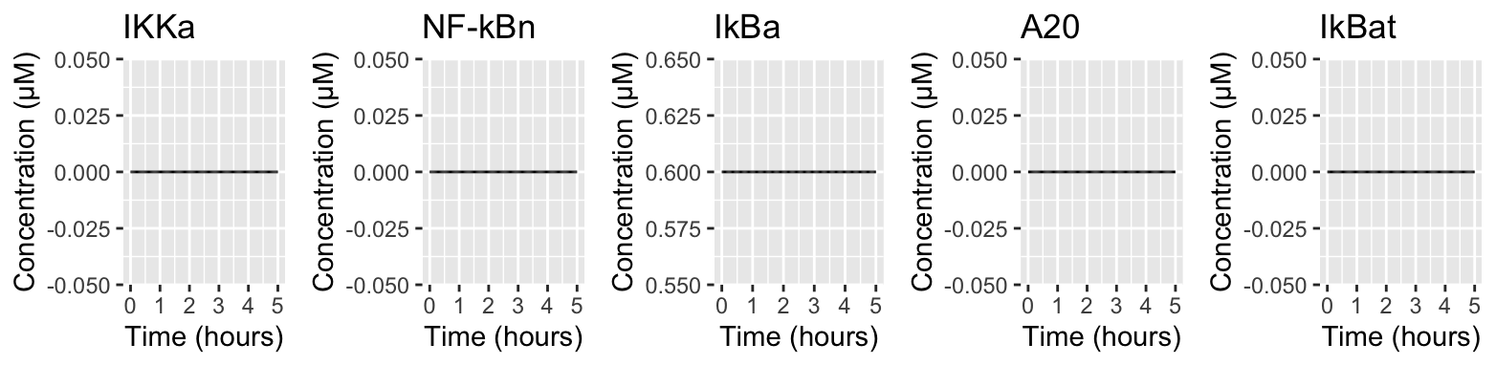

When compairing our model to the results in the article we saw that our model more or less captures the right dynamics, but the initial concentration values are incorrect. We have therefore changed the initial values to:

x0 <- c(IKKn = 1, IKKa = 0, NFkBn = 0, A20 = 0, IkBa = 0.3, IkBat = 0)

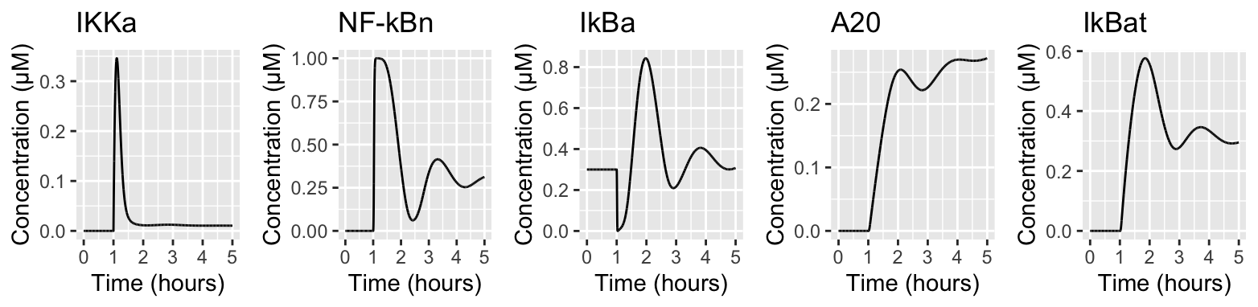

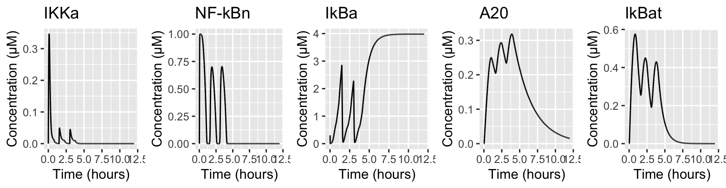

x0 <- c(IKKn = 1, IKKa = 0, NFkBn = 0, A20 = 0, IkBa = 0.6, IkBat = 0)

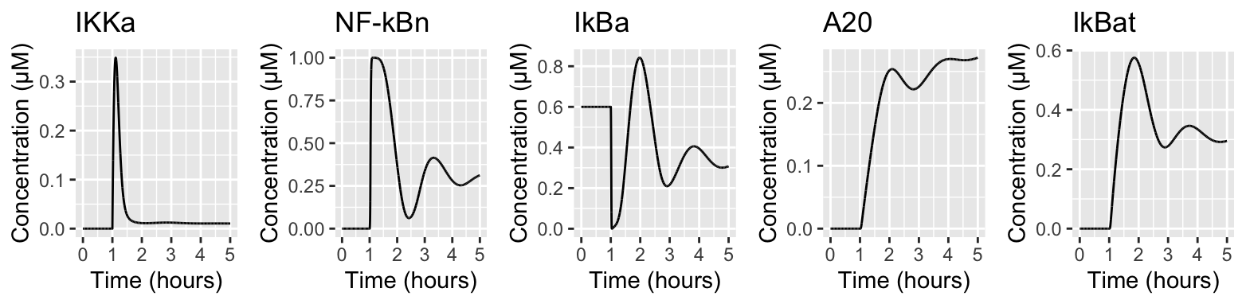

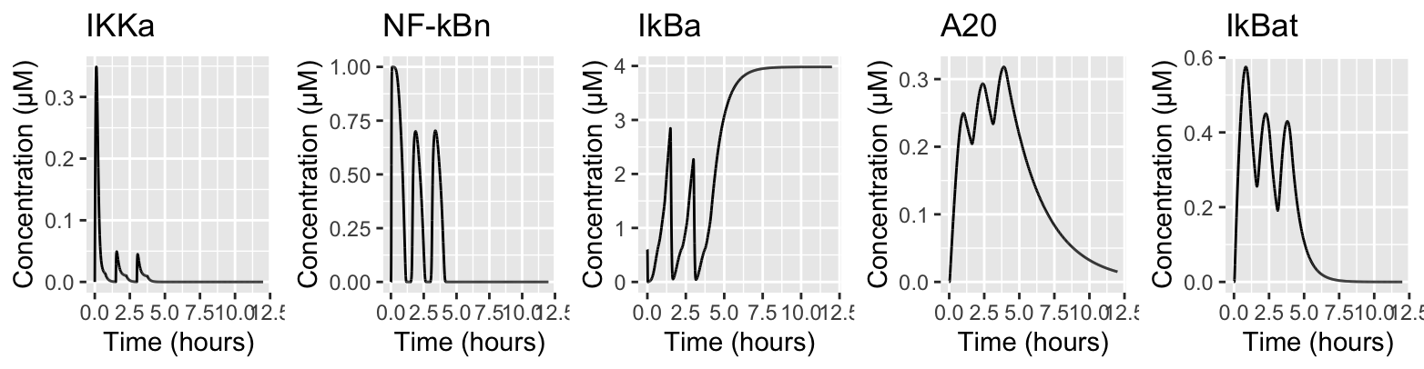

When removing the spontaneous degradation of IkBa the concentration when inactivating TNFa (the receptor) increases to a steady state instead of increasing and then decreasing due to the spontaneous degradation.

### Figure 8

Three types of the oscillatory responses of the reduced model to tonic TFN stimulation: Left subpanels show nuclear NFκBn(t) in response to tonic TNF stimulation started at t = 1 hour, whereas the right subpanels show trajectories projected on the (NFκBn, IκBα) plane.

Initial values:

x0 <- c(IKKn = 1, IKKa = 0, NFkBn = 0, A20 = 0, IkBa = 0, IkBat = 0)

a2 = 0.0762, c5a = 0.000058, i1a = 0.000595

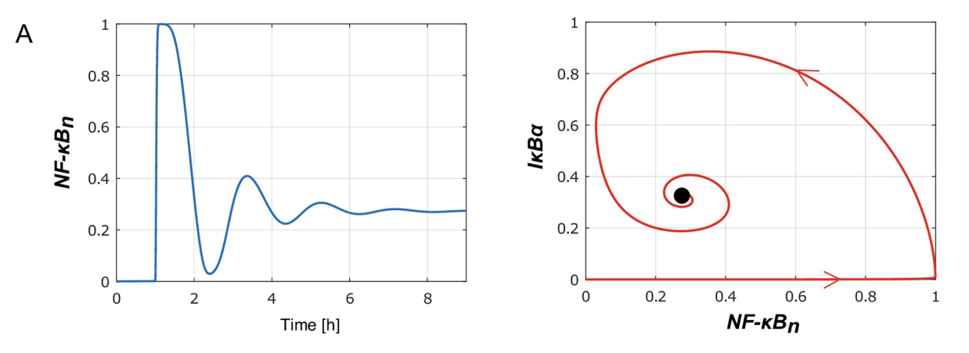

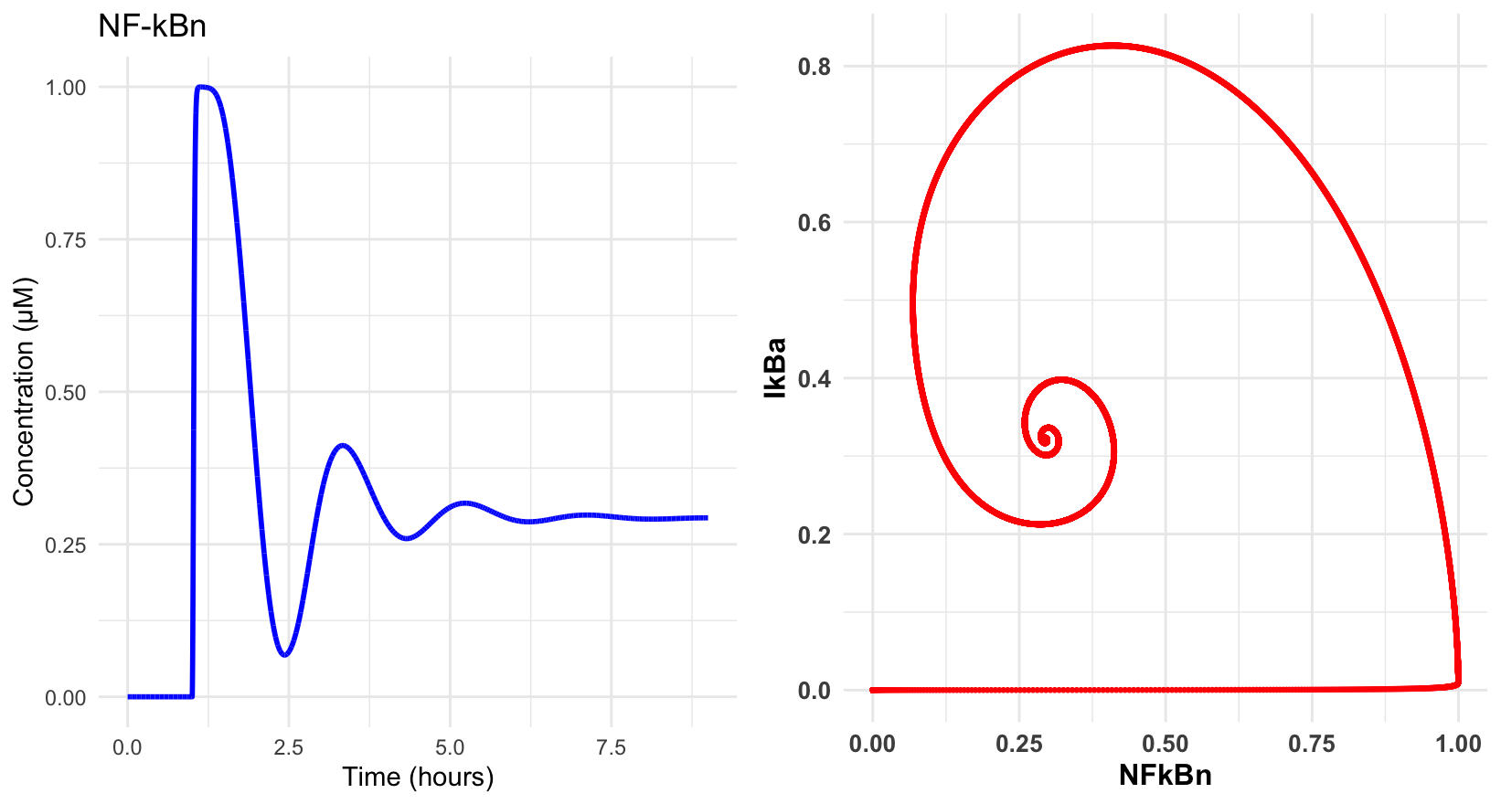

a2 =0.02, c5a = 0.00001, i1a = 0.0001

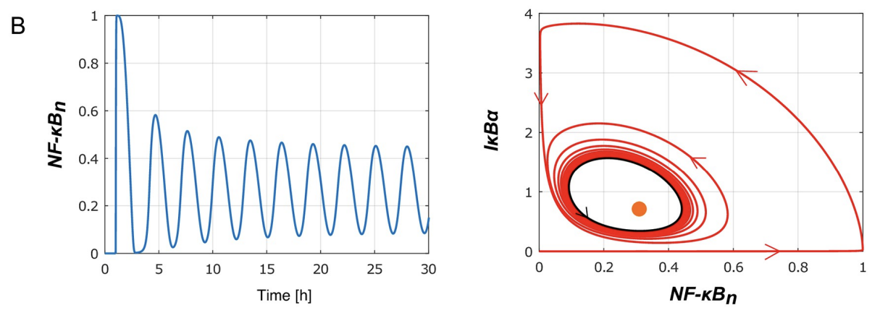

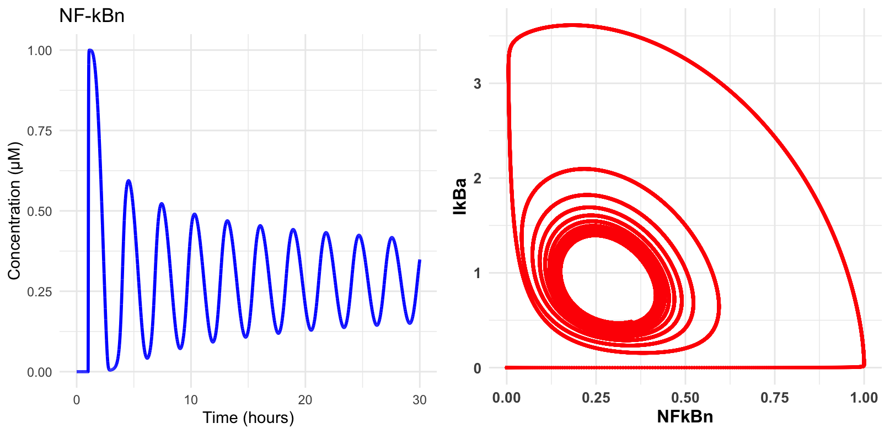

a2 =0.01, c5a = 0.00001, i1a = 0.0001

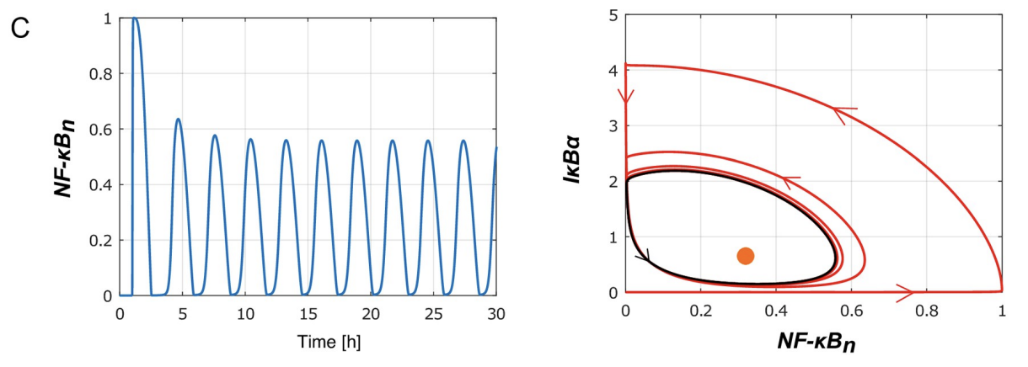

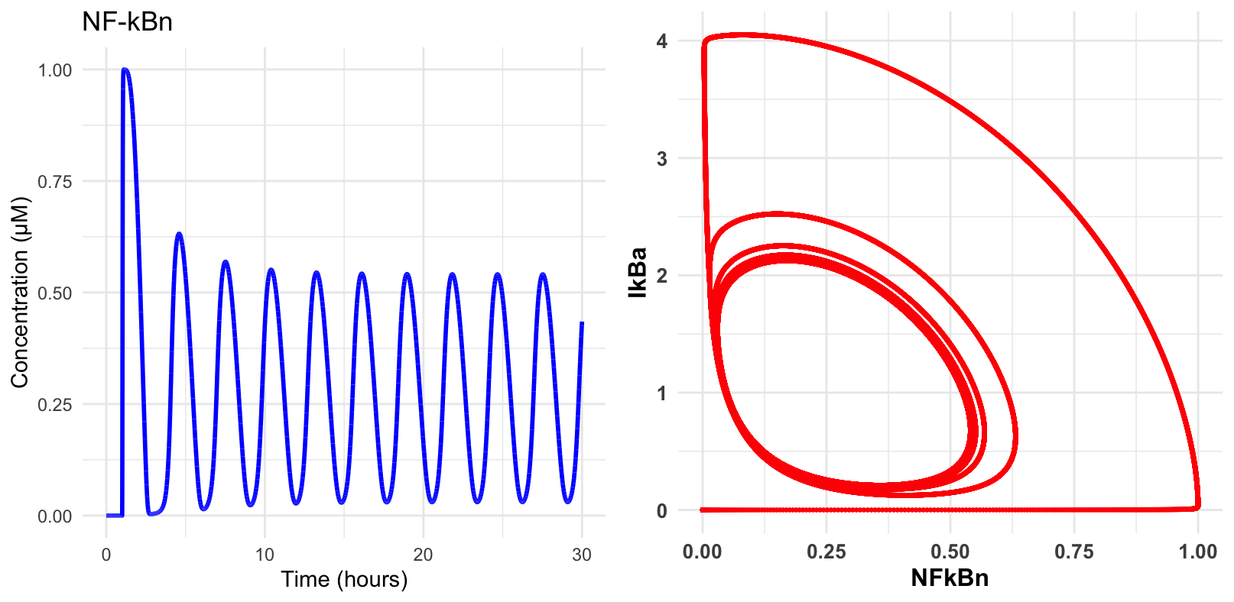

### Figure 9

Influence of A20 feedback on the reduced model responses to tonic TNF stimulation.

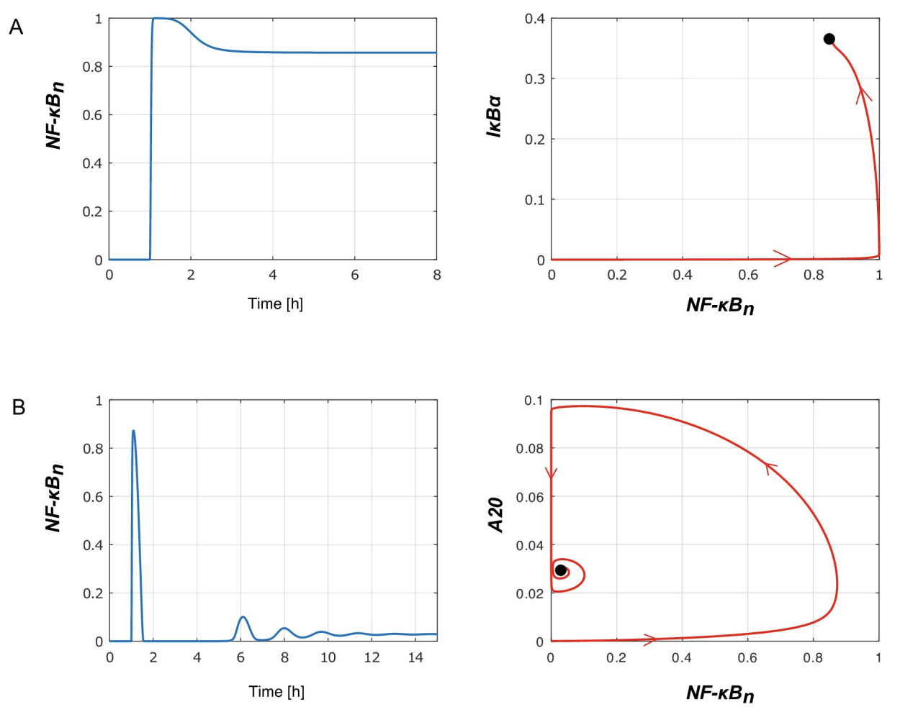

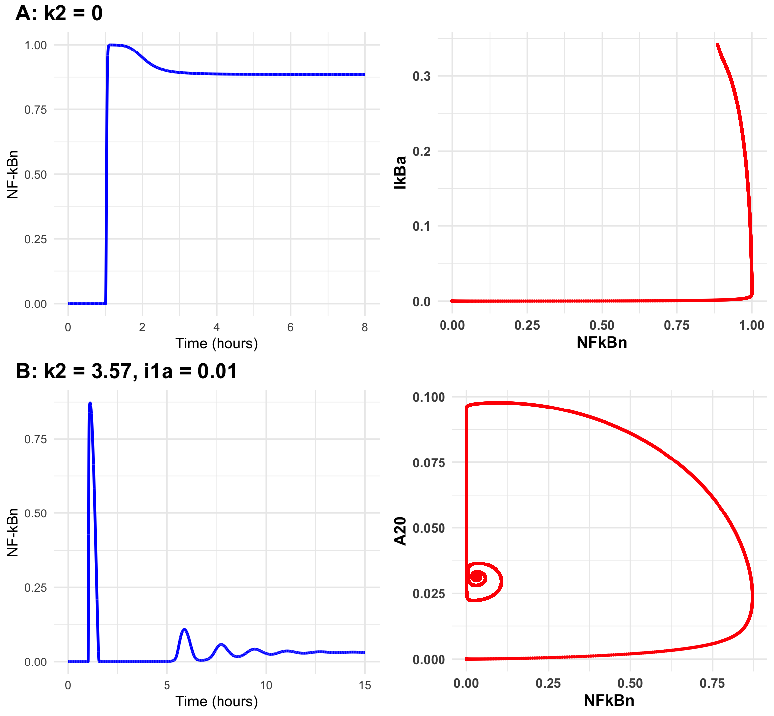

### Sensitivity analysis - SOBOL

* The **left panel** shows **first-order Sobol’ indices**, representing the individual effect of each parameter on the model output.
* The **right panel** shows **total Sobol’ indices**, representing the overall effect, including interactions with other parameters.

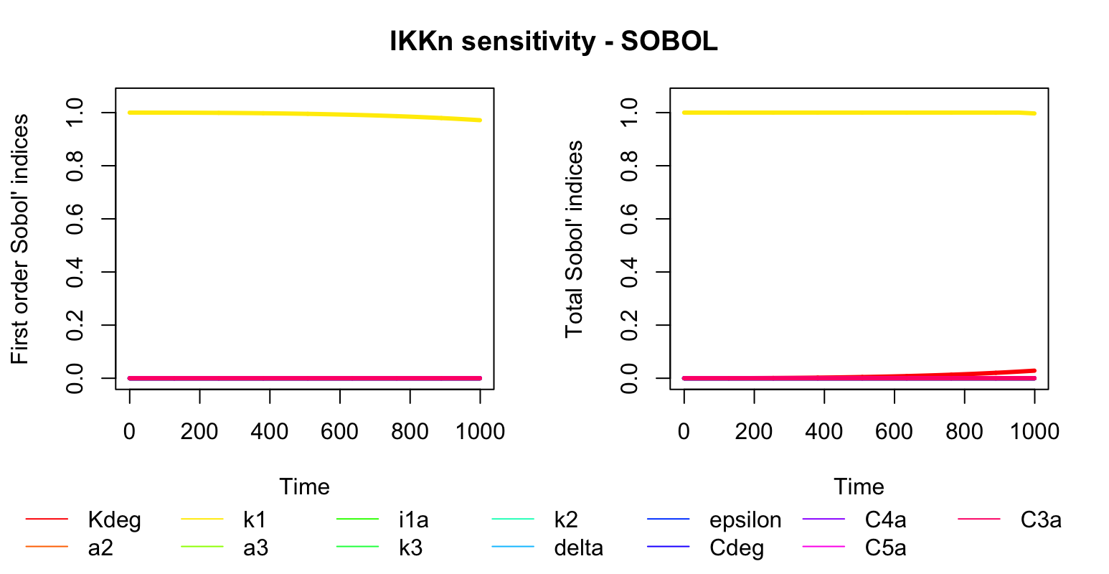

#### IKKa

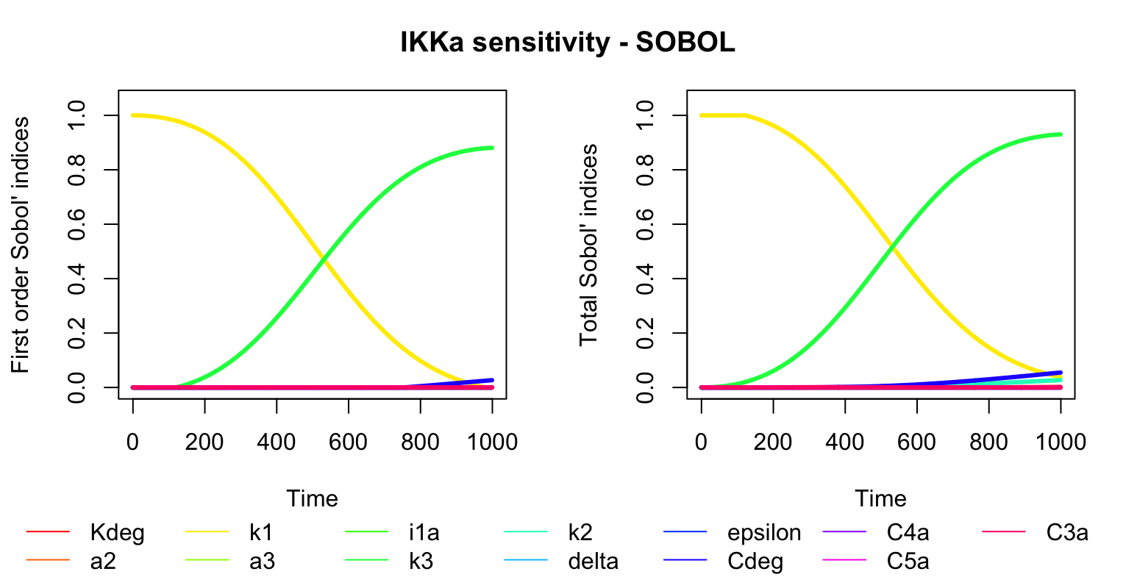

#### NF-kBn

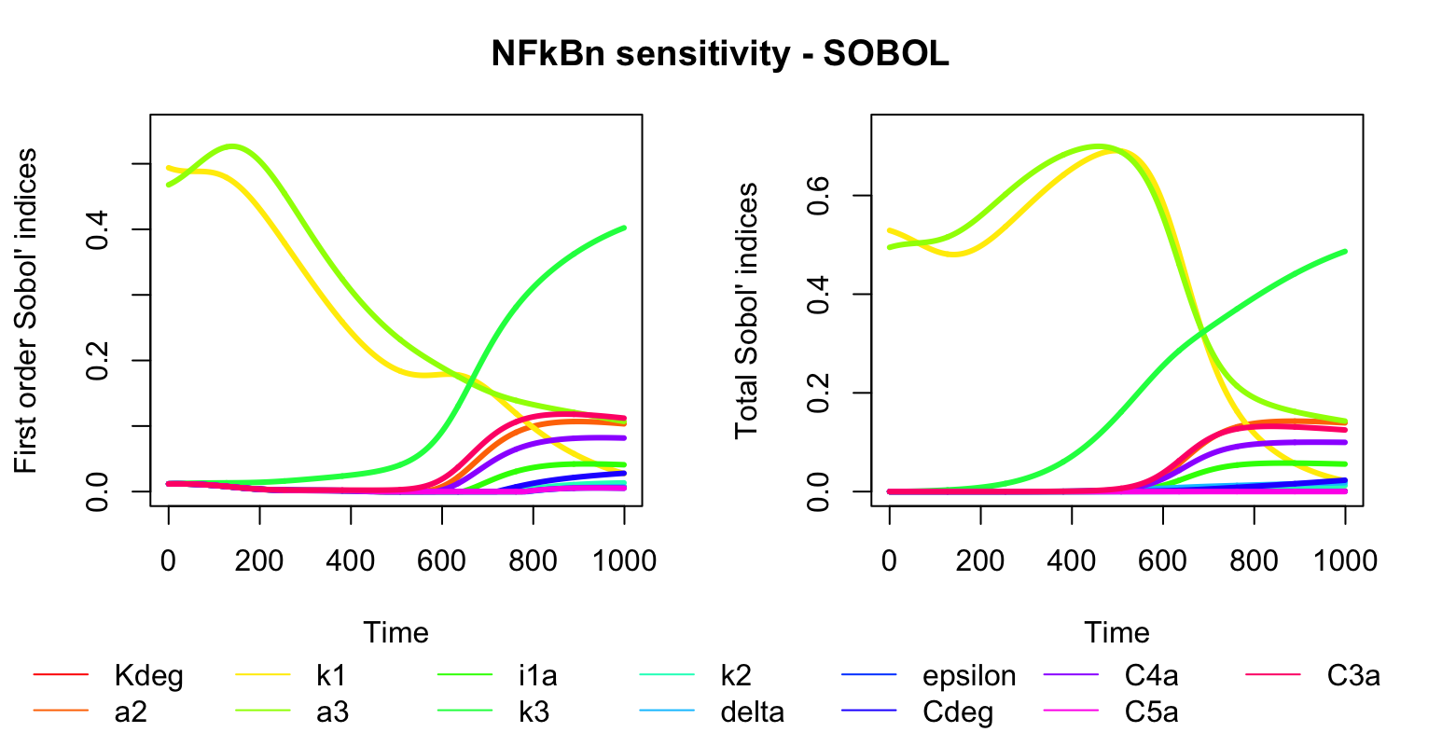

#### A20

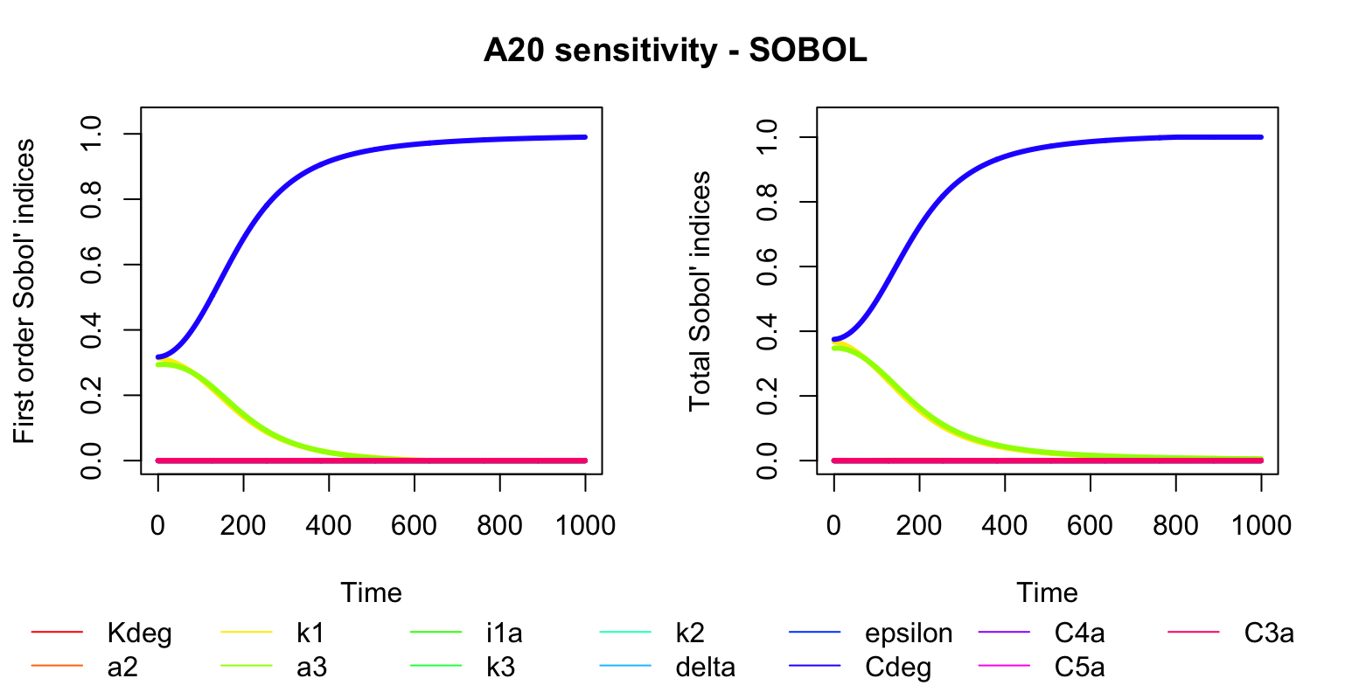

#### IkBa

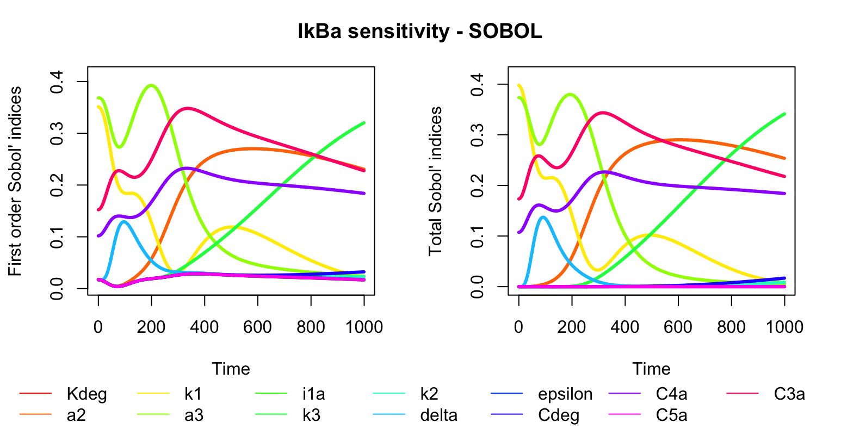

#### IkBat

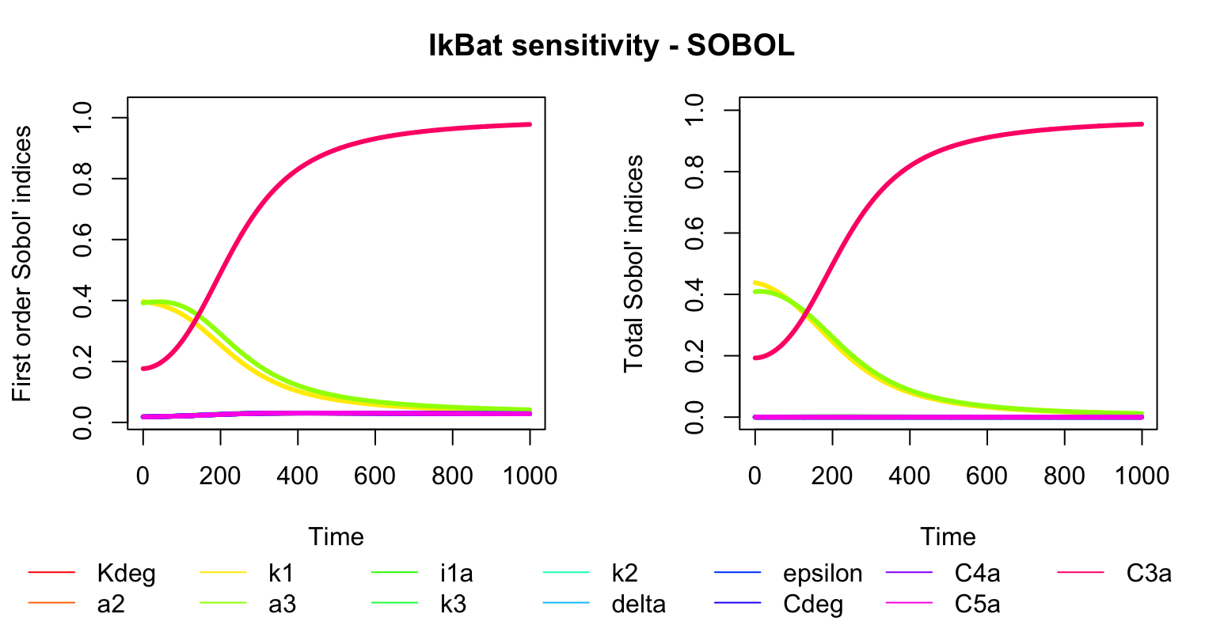

## Therapy

Increasing degradation of IKKa by increasing C5a and a2 by 0%, 25%, 50%, 75%, 100% respectively

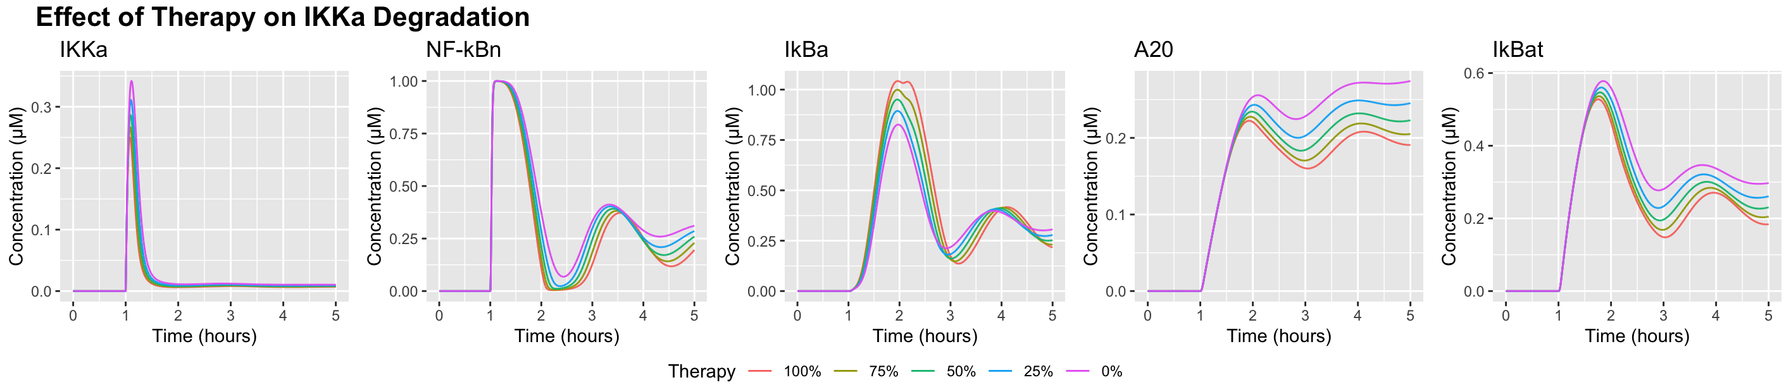

Increasing degradation of IkBa by increasing k2 and k3 by 0%, 25%, 50%, 75%, 100% respectively

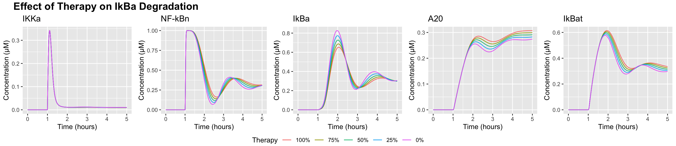

Decreasing degradation of IkBa by decreasing k2 and k3 by 0%, 25%, 50%, 75%, 100% respectively

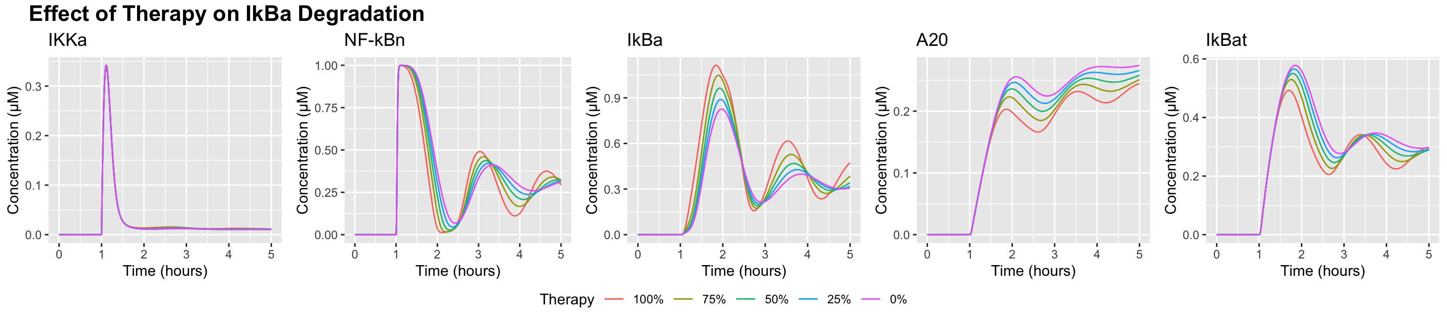

Decreasing the translation of IkBat into IkBa by decreasing C4a by 0%, 25%, 50%, 75%, 100% respectively

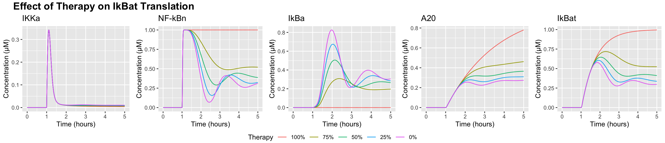

Decreasing NFkBn release from complex by decreasing a3 by 0%, 25%, 50%, 75%, 100% respectively

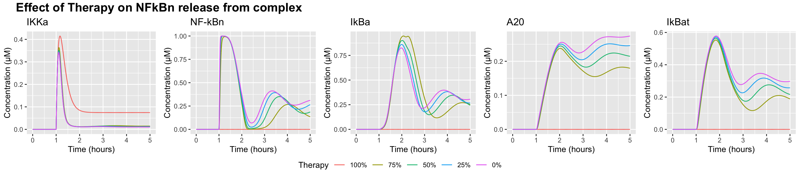

Increasing NFkBn and IkBa complex formation by increasing i1a by 0%, 25%, 50%, 75%, 100% respectively

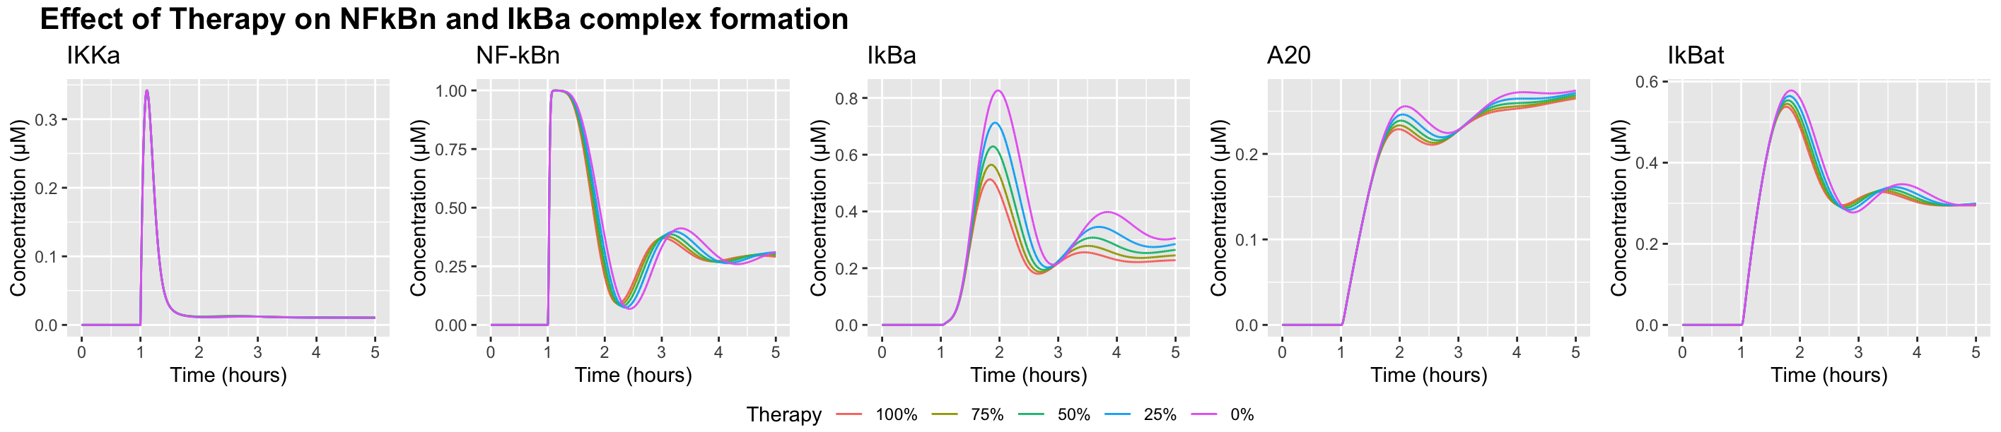

Decreasing NFkBn binding to DNA (decrease A20 and IkBat activation/degradation) by decreasing C3a and Cdeg by 0%, 25%, 50%, 75%, 100% respectively

